MCj03463170000[1]Safety Instruction

1. Users are required to read the operation manual completely and carefully before installation or operation.
2. This product must be installed or operated by properly trained personnel. All power must be turned off during installation, and remember not to operate with power.
3. All the instruction marked with sign MCj03463170000[1] must be observed or executed; otherwise, bodily injuries might occur.
4. For perfect operation and safety, it is prohibited that using extension cable with multi-outlet for power connection.
5. When connecting power supply cords to power sources, it is necessary to make sure that the power voltage matches the rated voltage ±20% indicated on the motor’s name plate.
6. Do not operate in direct sun light, outdoors area and where the room temperature is over 45°C or below 0°C.
7. Please avoid operating near the heater at dew area or at the humidity below 10% or above 90%.
8. Do not operate in area with heavy dust, corrosive substance or volatile gas.
9. Avoid power cord being applied by heavy objects or excessive force, or over bend.
10. The earth wire of power cord must be connected to the system ground of the production plant by proper size of conductions and terminals. This connection should be fixed permanently.
11. All the moving portions must be prevented to be exposed by the parts provided.
12. Turing on the machine in the first time, operate the sewing machine at low speed and check the correct rotation direction.
13. Turn off the power before the following operation：

1. Connecting or disconnecting any connectors on the control box or motor.

2. Threading needle.

3. Raising the machine head.

4. Repairing or doing any mechanical adjustment.

5. Machines idling.

1. Repairs and high level maintenance work should only be carried out by electronic technicians with appropriate training.
2. All the spare parts for repair must be provided or approved by the manufacturer.
3. Don’t use any objects or force to hit or ram the product.

**Guarantee Time**

Warranty period of this product is 1 year dated from purchasing, or within 2 years from ex-factory date.

**Warranty Detail**

Any trouble found within warranty period under normal operation, it will be repaired free of charge. However, maintenance cost will be charged in the following cases even if within warranty period:

1. Inappropriate use, including: wrong connecting high voltage, wrong application, disassemble, repair, modification by incompetent personnel, or operation without the precaution, or operation out of its specification range, or inserting other objects or liquids into the product.

2. Damage by fire, earth quake, lighting, wind, flood, salt corrosive, moisture, abnormal power voltage and any other damage cause by the natural disaster or by the inappropriate environments.

3. Dropping after purchasing or damage in transportation by customer himself or by customer’s shipping agency

Note: We make our best effort to test and manufacture the product for assuring the quality. However, it is possible that this product can be damaged due to external magnetic interference and electronic static or noise or unstable power source more than expected; therefore the grounding system of operate area must guarantee the good earth and it’s also recommended to install a failsafe device (such as residual current breaker).

**1. Interface and operation instructions**

**1.1 Main interface description**

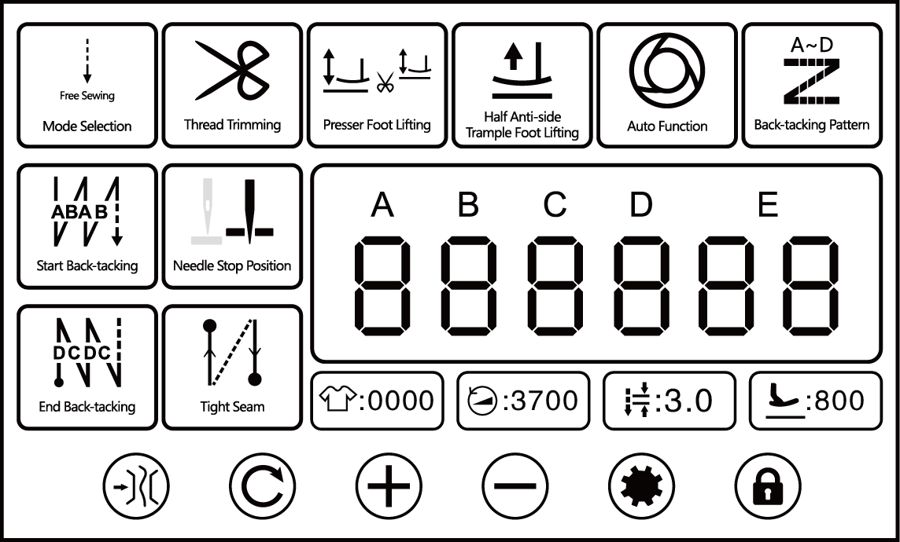

|  |  |  |
| --- | --- | --- |
| Name | Key | Indicate |
| Clamp function setting |  | If click, set used or cancelled clamp function. |
| Constant stitch sewing switching key |  | In constant stitch sewing mode, if click, switch to stitch numbers and segments display interface. |
| Parameter increase |  | If click, it can increase parameters.  If long-press, it can continuously increase parameters. |
| Parameter decrease |  | If click, it can decrease parameters.  If long-press, it can continuously decrease parameters. |
| Set key |  | If click, enter the parameter setting interface. |
| Lock screen key |  | If you click, switch the lock screen and unlock. |
| Mode selection |  | If click, shift to free sewing, continuous back seam mode, constant stitch sewing and pattern seam mode. |
| Start back-tacking |  | If click, executions starting back seam B segment, execution starting back seam (A, B segment) 1 time or execution starting back seam (A, B segment) 2 times.  If long-press, switch to back-tacking setting. |
| End back-tacking |  | If click, execution terminates back seam C segment, execution terminates back seam (C, D segment) 1time or execution terminates back seam (C, D segment) 2 times.  If long-press, switch to back-tacking setting. |
| Thread trimming |  | If click, set used or cancelled trimming function. |
| Needle stop position |  | If click, switch the needle stop position after sewing (up position / down position). |
| Tight seam |  | If click, switch between function OFF, starting tight seam function ON, ending tight seam function ON and full function in turn.  If long-press, switch to tight seam function setting. |
| Presser foot lifting |  | If click, switch between automatic presser foot lifting after pause, automatic presser foot lifting after trimming, full function and function off in turn. |
| Half anti-side trample foot lifting |  | If click, set used or cancelled half anti-side trample foot lifting function. |
| Auto function |  | In constant stitch sewing mode, If click, set used or cancelled auto function. |
| Back-tacking pattern |  | If click, set used or cancelled back-tacking pattern function. |
| Slow launch setting |  | If click, set used or cancelled slow launch function. |
| Advanced parameter settings |  | If double click, enter the advanced parameter setting interface. |
| Trimming count display |  | The trimming count value is displayed.  If double click, the count is cleared. |
| Sewing speed display |  | The sewing speed of the current mode is displayed.  If click, select this data, and you can adjust the data by parameter increase and decrease keys. |
| Sewing stitch length display |  | The stitch length of the current mode is displayed.  If click, select this data, and you can adjust the data by parameter increase and decrease keys. |
| The highest presser foot height display |  | The highest presser foot height is displayed.  If click, select this data, and you can adjust the data by parameter increase and decrease keys. |

**1.2 Pattern seam interface description**

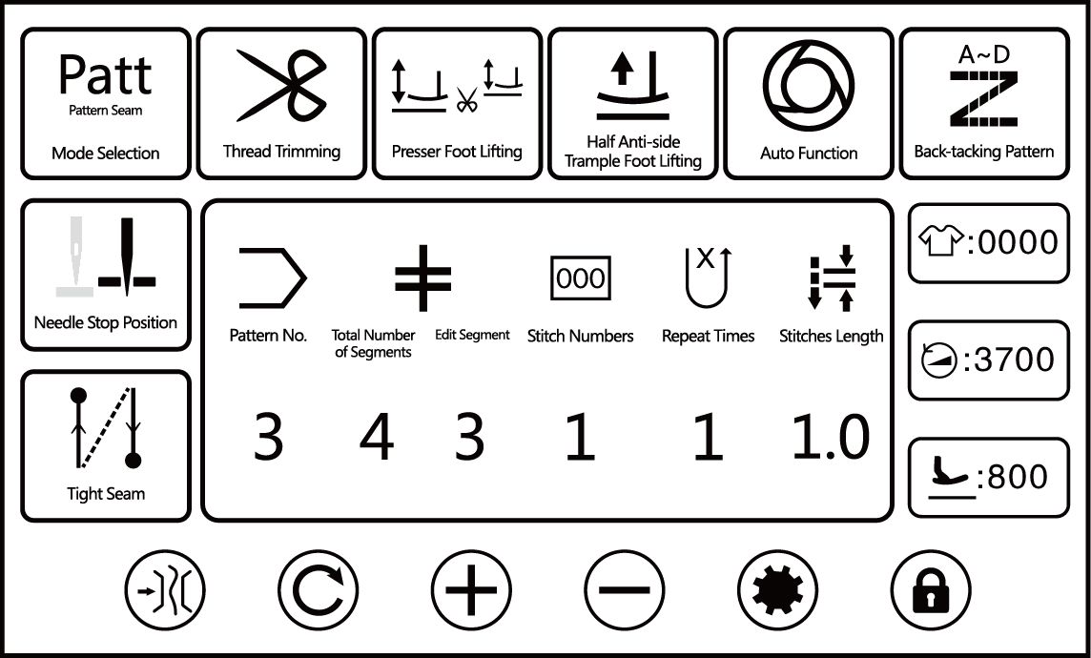

|  |  |  |  |  |
| --- | --- | --- | --- | --- |
| No. | Items | Range | Default | Description |
| 1 |  | 1-9 |  | "3" stands for the number of the pattern. The figure represents the 3rd pattern. |
| 2 |  | 1-10 |  | "4" represents the total number of segments of the pattern. If you click, you can select the total number of segments.  "3" represents the segment No. of the pattern.  As shown in the figure, there are 4 patterns in the 3rd pattern. The figure is the data of the 3rd segment. |
| 3 |  | 1-99 |  | "1" represents the stitch numbers of the pattern. As shown in the figure, the number of stitches in the 3rd segment of the 3rd pattern is 1. |
| 4 |  | 1-9 |  | "1" represents the repeat times of the pattern. As shown in the figure, the repeat times for the 3rd segment of the 3rd pattern is 1. |
| 5 |  | 0-5.0 |  | "1.0" represents the stitches length of this pattern. As shown in the figure, the stitches length of the 3rd segment of the 3rd pattern is 1.0 mm. |

**1.3 Constant stitch sewing interface description**

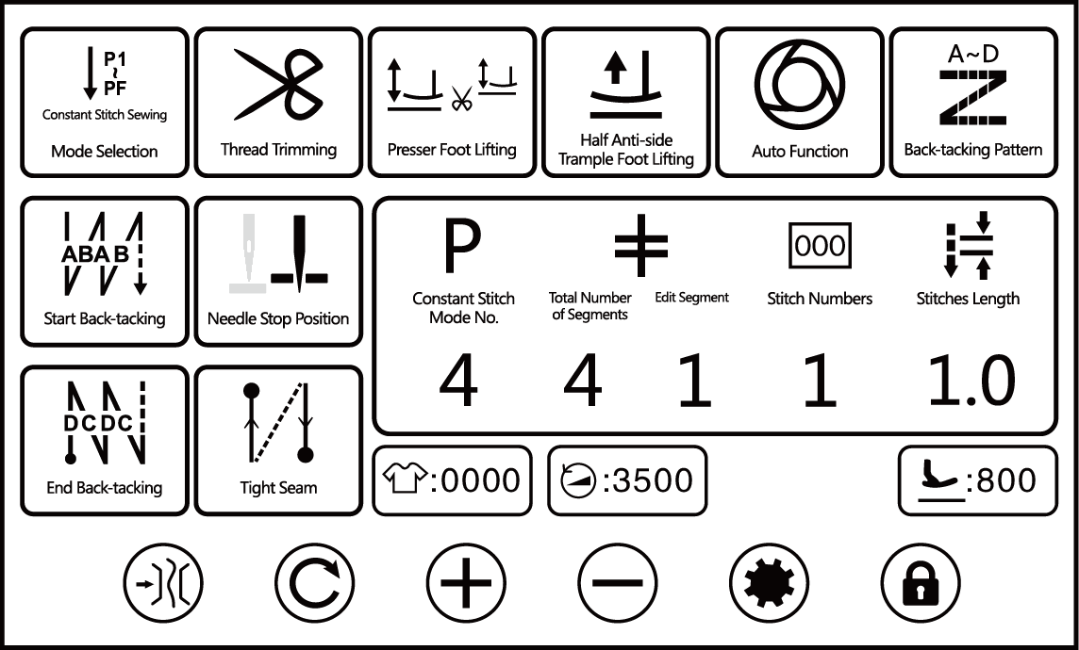

|  |  |  |  |  |
| --- | --- | --- | --- | --- |
| No. | Items | Range | Default | Description |
| 1 |  | 1-10 |  | "4" represents the number of constant stitch sewing mode. As shown in the figure, it represents 4th constant stitch sewing mode. |
| 2 |  | 1-4 |  | "4" represents the total number of segments of the constant stitch sewing mode. If clicked, the total number of segments can be selected.  "1" represents the segment No. of constant stitch sewing.  As shown in the figure, it represents the data of the 1st segment of the 4 segments. |
| 3 |  | 0-99 |  | "1" represents the number of stitches in this segment. As shown in the figure, the number of stitches in the 1st segment of the 4 segments is 1. |
| 4 |  | 0-5.0 |  | "1.0" represents the stitches length of the constant stitch sewing mode. As shown in the figure, the stitches length of the 1st segment of the 4 segments is 1.0mm. |

**1.4 Debug interface description**

Long press  on the main screen, the debugging interface will be displayed.

|  |  |  |  |  |  |
| --- | --- | --- | --- | --- | --- |
| No. | Items | Range | Default | Description | Parameter |
| 1 | Main shaft motor zero-point correction |  |  |  | P92 |
| 2 | Up position quick adjustment |  |  |  | P72 |
| 3 | Back-tacking motor zero-point correction | -100～100 | 0 |  | P129 |
| 4 | Tacking stitch length compensation | -100～100 | 0 |  | P74 |
| 5 | Back-tacking stitch length compensation | -100～100 | 0 |  | P75 |
| 6 | Tacking stitch length compensation in high speed | -100～100 | 0 |  | P144 |
| 7 | Back-tacking stitch length compensation in high speed | -100～100 | 0 |  | P145 |
| 8 | Back-tacking stitch overall compensation | -20～20 | 0 |  | P11 |
| 9 | Large stitch length back-tacking stitch overall compensation | -20～20 | 0 |  | P244 |

**2. User parameter setting interface**

Click  in the interface of free sewing, pattern seam, or W sewing to enter user parameter setting interface. The parameter setting interface catalog is as follows.

|  |  |
| --- | --- |
| No. | Setting |
| 1 | Main shaft motor setting |
| 2 | Tight seam function setting |
| 3 | Back-tacking setting |
| 4 | Counter setting |
| 5 | Soft start setting |
| 6 | Machine switch setting |
| 7 | Clamp & tension setting |
| 8 | Interface display |
| 9 | Layer seam setting |
| 10 | Clamp function without any thrum |

|  |  |  |  |  |  |
| --- | --- | --- | --- | --- | --- |
| No. | Items | Range | Default | Description | Parameter |
| 2.1 Main shaft motor setting | | | | | |
| 2101 | Needles goes up automatically as power turned on | OFF/ON | OFF |  |  |
| 2.2 Tight seam function setting | | | | | |
| 2201 | Starting tight seam |  |  |  |  |
| 2202 | Ending tight seam |  |  |  |  |
| 2.2.1 Starting tight seam | | | | | |
| 22101 | QQ截图20190914195705 | 0-12 | 2 | When the value is 0, the starting tight seam mode is turned off. |  |
| 22102 | QQ截图20190914195715 | 0-5.0 | 0.5 | Stitches length |  |
| 22103 | QQ截图20190914195728 | 100-2000 | 1800 | Speed |  |
| 22104 | QQ截图20190914195738 | CW/CCW | CW | Direction |  |
| 2.2.2 Ending tight seam | | | | | |
| 22201 | QQ截图20190914195705 | 0-12 | 2 | When the value is 0, the ending tight seam mode is turned off. |  |
| 22202 | QQ截图20190914195715 | 0-5.0 | 0.5 | Stitches length |  |
| 22203 | QQ截图20190914195728 | 100-2000 | 1800 | Speed |  |
| 22204 | QQ截图20190914195738 | CW/CCW | CW | Direction |  |
| 2.3 Back-tacking setting | | | | | |
| 2301 | Start back-tacking speed | 200-3200 | 2000 |  | P04 |
| 2302 | End back-tacking speed | 200-3200 | 2000 |  | P05 |
| 2303 | Mode selection for bar-tacking | OFF/ON | ON |  | P08 |
| 2304 | The constant-stitch whether can execute end back-tacking sewing function selection | OFF/ON | ON |  | P10 |
| 2305 | Star back-tacking mode selection | OFF/ON | ON |  | P12 |
| 2306 | Mode selection at the end of start back-tacking | OFF/ON | ON |  | P13 |
| 2307 | Start back-tacking stitch compensation 1 | 0-200 | 160 |  | P18 |
| 2308 | Start back-tacking stitch compensation 2 | 0-200 | 160 |  | P19 |
| 2309 | End back-tacking stitch compensation 3 | 0-200 | 160 |  | P25 |
| 2310 | End back-tacking stitch compensation 4 | 0-200 | 160 |  | P26 |
| 2311 | Back-tacking stitch compensation 5 | 0-200 | 160 |  | P32 |
| 2312 | Back-tacking stitch compensation 6 | 0-200 | 160 |  | P33 |
| 2313 | Start back-tacking stitch compensation 11 | 0-200 | 160 |  | P237 |
| 2314 | Start back-tacking stitch compensation 12 | 0-200 | 160 |  | P238 |
| 2315 | End back-tacking stitch compensation 13 | 0-200 | 160 |  | P239 |
| 2316 | End back-tacking stitch compensation 14 | 0-200 | 160 |  | P240 |
| 2317 | Back-tacking stitch compensation 15 | 0-200 | 160 |  | P241 |
| 2318 | Back-tacking stitch compensation 16 | 0-200 | 160 |  | P242 |
| 2319 | Pattern sewing compensation 1 | 0-200 | 160 |  | P235 |
| 2320 | Pattern sewing compensation 2 | 0-200 | 160 |  | P236 |
| 2.4 Counter setting | | | | | |
| 2401 | Counter selection | 0-2 | 1 | 0: Counter does not count  1: Count up sewing counter (Each time the thread is cut, the count is increased by 1; the current value and the set value are the same, and the count screen is displayed.)  2: Count-down sewing counter (1 counts each time the thread is trimmed; the count screen is displayed after the current value becomes 0) |  |
| 2402 | Counter current value /setting value | 0-9999 | 0/9999 | The current value is the current actual value; the setting value is a reference value |  |
| 2403 | Sewing counter trimming time | 0-50 | 1 |  |  |
| 2.5 Soft start setting | | | | | |
| 2501 | Soft start switch | ON/OFF | OFF |  | P14 |
| 2502 | Stitch numbers for soft start | 1-15 | 1 |  | P08 |
| 2503 | Soft start first stitch speed | 200-1500 | 400 |  | P90 |
| 2504 | Soft start second stitch speed | 200-1500 | 1000 |  | P91 |
| 2505 | Soft start speed after second stitch | 200-1500 | 1500 |  | P07 |
| 2.6 Machine switch setting | | | | | |
| 2601 | Manual switch A setting | 0-6 | 5 | 0: OFF  1: Half stitch  2: One stitch  3: Continuous half stitch  4: Continuous one stitch  5: Back-tacking when machine stop or pause  6: Tight seam function | P15 |
| 2602 | Manual switch B setting | 0-6 | 3 | 0: OFF  1: Half stitch  2: One stitch  3: Continuous half stitch  4: Continuous one stitch  5: Back-tacking when machine stop or pause  6: Tight seam function | P174 |
| 2603 | Manual switch C setting | 0-6 | 0 | 0: OFF  1: Half stitch  2: One stitch  3: Continuous half stitch  4: Continuous one stitch  5: Back-tacking when machine stop or pause  6: Tight seam function | P175 |
| 2604 | Manual switch D setting | 0-6 | 0 | 0: OFF  1: Half stitch  2: One stitch  3: Continuous half stitch  4: Continuous one stitch  5: Back-tacking when machine stop or pause  6: Tight seam function | P176 |
| 2605 | Manual back-tacking function selection under pattern sewing | 0-1 | 1 | 0: If click, it will clear the current number of pattern stitches and restart. It is used for corner sewing to avoid protruding one stitch.  1: If you press it for a long time, you can sew the pattern backwards. | P118 |
| 2.7 Clamping & tension setting | | | | | |
| 2701 | Tension strength setting | 1-80 | 30 |  | P103 |
| 2702 | With or without tension while foot lifting action | ON/OFF | OFF |  | P35 |
| 2703 | Wiping / clamping strength setting | 0-11 | 9 | 0: OFF  1: Wiping function  2～11: Clamping function, the higher the value, the stronger the action. | P37 |
| 2704 | Tension function switch | ON/OFF | ON |  | P36 |
| 2705 | The foot lift height of thread tension release start action when knee-control foot lift | 0-300 | 75 |  | P30 |
| 2706 | Thread tension release function switch when knee-control foot lift | 0-1 | 0 |  | P31 |
| 2.8 Interface display | | | | | |
| 2801 | Brightness | 5-100 | 80 | The larger the value, the higher the brightness. |  |
| 2802 | Main interface locked automatically | 0-900 | 60 |  |  |
| 2803 | Restore factory defaults |  |  |  |  |
| 2804 | Language | Chinese / English | Chinese |  |  |
| 2805 | Brightness of Logo light | 0-3 | 0 |  |  |
| 2.9 Layer seam setting | | | | | |
| 2901 | Layer seam mode switch | ON/OFF | OFF |  | P119 |
| 2.10 Clamp function without any thrum | | | | | |
| 21001 | Clamp function without any thrum switch | ON/OFF | OFF |  | P111 |

**3. Advanced parameter setting interface**

Double-click  in the interface of free sewing, pattern seam, or W sewing to enter the advanced parameter setting interface. The parameter setting interface catalog is as follows.

|  |  |
| --- | --- |
| No. | Setting |
| 1 | Trimming function setting |
| 2 | Clamp function setting |
| 3 | Foot lifting setting |
| 4 | Tension setting |
| 5 | Pedal setting |
| 6 | Safety protection setting |
| 7 | Stitch length setting of stepping back-tacking |
| 8 | Testing mode |
| 9 | State information |
| 10 | Main shaft motor setting |
| 11 | Clamp function without any thrum |
| 12 | Layer seam setting |
| 13 | Other settings |
| 14 | Speed limit setting of main shaft motor start sewing |

|  |  |  |  |  |  |  |  |  |  |  |  |
| --- | --- | --- | --- | --- | --- | --- | --- | --- | --- | --- | --- |
| No. | Items | | | Range | Default | | Description | | | | Parameter |
| 3.1 Trimming function setting | | | | | | | | | | | |
| 3101 | Trimming step return speed | | | 20-400 | 250 | |  | | | |  |
| 3102 | Trimming first section speed | | | 20-400 | 200 | |  | | | |  |
| 3103 | Trimming second section speed | | | 20-400 | 150 | |  | | | |  |
| 3104 | Trimming action time | | | 10-990 | 200 | |  | | | |  |
| 3105 | The angle of trimming first infeed | | | 0-359 | 65 | |  | | | |  |
| 3106 | The angle of trimming second infeed | | | 0-359 | 175 | |  | | | |  |
| 3107 | First trimming distance | | | 0-200 | 68 | |  | | | |  |
| 3108 | Second trimming distance | | | 0-200 | 82 | |  | | | |  |
| 3109 | Trimming step return time | | | 10-990 | 100 | |  | | | |  |
| 3.2 Clamp function setting | | | | | | | | | | | |
| 3201 | Clamp start angle | | | 10-359 | 100 | |  | | | | P78 |
| 3202 | Clamp end angle | | | 10-359 | 270 | |  | | | | P79 |
| 3203 | Wiper thread action time | | | 10-990 | 220 | |  | | | | P55 |
| 3204 | The delay time before wiper thread | | | 5-990 | 5 | |  | | | | P109 |
| 3.3 Presser foot setting | | | | | | | | | | | |
| 3301 | Presser foot lay down time | | | 10-990 | 120 | |  | | | | P52 |
| 3302 | Presser foot lift highness compensation when pedal return to intermediate step at sewing stop | | | 0-160 | 80 | | Set 80 as 0 compensation, go to the major adjustment for positive compensation, the height of the presser foot will increase, go to the minor adjustment for the negative compensation, the height of the presser foot will decrease. | | | | P125 |
| 3303 | The highest of presser foot lift highness | | | 0-300 | 105 | |  | | | | P136 |
| 3304 | Presser foot speed | | | 20-400 | 250 | |  | | | | P146 |
| 3305 | Zero correction of foot lifting motor | | | -100～100 | 0 | |  | | | | P130 |
| 3306 | Presser foot step motor steady current | | | 10-100 | 25 | |  | | | | P150 |
| 3307 | Presser foot motor maximum current | | | 10-100 | 40 | |  | | | | P152 |
| 3308 | Electronic knee-control device the lowest presser foot lift height | | | 0-200 | 20 | |  | | | | P135 |
| 3309 | Electronic knee-control device the highest presser foot lift height | | | 0-200 | 130 | |  | | | | P126 |
| 3310 | The highest of presser foot lift highness limit | | | 0-300 | 150 | |  | | | | P172 |
| 3311 | Kneeling device starting AD value | | | 0-1023 | 400 | |  | | | | P122 |
| 3312 | Rotation direction of the presser foot motor | | | 0-1 | 0 | |  | | | | P147 |
| 3313 | Knee-control function selection | | | 0-2 | 1 | | 0: OFF  1: Valid when the main shaft motor stops  2: Valid when the main shaft motor runs and stops | | | | P127 |
| 3314 | The highest presser foot lift height of electric knee-control in sewing | | | 0-300 | 100 | |  | | | |  |
| 3.4 Tension setting | | | | | | | | | | | |
| 3401 | Tension starting angle | | | 1-359 | 30 | |  | | | | P101 |
| 3402 | Tension ending angle | | | 1-359 | 180 | |  | | | | P102 |
| 3403 | Periodic signal of the first thread tension release output action (%) | | | 1-100 | 35 | |  | | | | P211 |
| 3404 | Thread tension release the first output action time | | | 1-100 | 20 | |  | | | | P212 |
| 3.5 Pedal setting | | | | | | | | | | | |
| 3501 | Speed curve adjustment (%) | | | 10-100 | 80 | |  | | | | P02 |
| 3502 | The voltage of forward step pedal point | | | 30-1000 | 520 | |  | | | | P21 |
| 3503 | The voltage of intermediate step pedal point | | | 30-1000 | 420 | |  | | | | P22 |
| 3504 | The voltage of half heeling pedal point | | | 30-1000 | 270 | |  | | | | P23 |
| 3505 | The voltage of heeling pedal point | | | 30-1000 | 130 | |  | | | | P24 |
| 3506 | Delay time of half heeling pedal | | | 10-900 | 100 | |  | | | | P93 |
| 3.6 Safety protection setting | | | | | | | | | | | |
| 3601 | Machine protection switch testing | | | 0-2 | 1 | | 0: OFF  1: Testing zero signal  2: Testing positive signal | | | | P66 |
| 3602 | Oil level lower protection testing | | | OFF/ON | OFF | |  | | | | P120 |
| 3603 | Setting high voltage protection value | | | 850-1023 | 880 | | When the external input AC voltage is converted into DC voltage and the value exceeds the set value, the system will alarm E01 and stop working. | | | | P89 |
| 3604 | Tension electromagnet protection time | | | 1-60 | 2 | | Electromagnet working protection time (S) | | | | P57 |
| 3605 | Trimming protection switch | | | OFF/ON | OFF | |  | | | | P67 |
| 3.7 Stitch length setting of stepping back-tacking | | | | | | | | | | | |
| 3701 | Back-tacking motor zero-point correction | | | -100～100 | 0 | |  | | | | P129 |
| 3702 | Normal stitch length | | | 0-6.0 | 3.0 | |  | | | | P131 |
| 3703 | Stitch length reference value setting | | |  |  | |  | | | |  |
| 3704 | Tacking stitch length compensation | | | -100～100 | 0 | |  | | | | P74 |
| 3705 | Back-tacking stitch length compensation | | | -100～100 | 0 | |  | | | | P75 |
| 3706 | Back-tacking stitch compensation | | | 0-200 | 0 | |  | | | | P243 |
| 3707 | Back-tacking step motor steady current | | | 1-100 | 6 | |  | | | | P149 |
| 3708 | Back-tacking step motor maximum current | | | 1-100 | 12 | |  | | | | P151 |
| 3709 | Manual close stitches distance | | | 0-6.0 | 2.0 | |  | | | | P132 |
| 3710 | Correction stitches distance of manual button A | | | 0-6.0 | 0 | |  | | | | P71 |
| 3711 | Correction stitches distance of manual button B | | | 0-6.0 | 0 | |  | | | | P170 |
| 3712 | Correction stitches distance of manual button C | | | 0-6.0 | 0 | |  | | | | P171 |
| 3713 | Correction stitches distance of manual button D | | | 0-6.0 | 0 | |  | | | | P173 |
| 3714 | Maximum stitch length limit | | | 0-8.0 | 6.0 | |  | | | | P123 |
| 3715 | Back-tacking response time when after free sewing end back-tacking start | | | 20-350 | 125 | |  | | | | P77 |
| 3716 | Large stitch length setting | | | 0-8.0 | 5.5 | |  | | | | P245 |
| 3717 | Speed limit of start back-tacking, end back-tacking and bar-tacking when in large stitch length setting | | | 200-3000 | 1600 | |  | | | | P246 |
| 3718 | Back-tacking corner stitch compensation 1 | | | -100～100 | 0 | |  | | | | P247 |
| 3719 | Back-tacking corner stitch compensation 2 | | | -100～100 | 0 | |  | | | | P248 |
| 3720 | Large stitch length tacking stitch length compensation in high speed | | | -100～100 | 0 | |  | | | |  |
| 3721 | Large stitch length back-tacking stitch length compensation in high speed | | | -100～100 | 0 | |  | | | |  |
| 3722 | Back-tacking step motor speed | | | 50-1000 | 500 | |  | | | |  |
| 3.7.3 Stitch length reference value setting | | | | | | | | | | | |
| Forward | | Stitch length | | | | | Backward | | Stitch length | | |
| 1mm | |  | | | | | 1mm | |  | | |
| 2mm | |  | | | | | 2mm | |  | | |
| 3mm | |  | | | | | 3mm | |  | | |
| 4mm | |  | | | | | 4mm | |  | | |
| 5mm | |  | | | | | 5mm | |  | | |
| 6mm | |  | | | | | 6mm | |  | | |
| 7mm | |  | | | | | 7mm | |  | | |
| 8mm | |  | | | | | 8mm | |  | | |
| 3.8 Testing mode | | | | | | | | | | | |
| 3801 | Testing mode switch | | | ON/OFF | OFF | | (Perform the cycle of start-sewing-stop-thread trimming at the test speed) | | | |  |
| 3802 | Output function single testing | | |  |  | |  | | | |  |
| 3803 | Testing mode setting | | |  |  | |  | | | |  |
| 3.8.2 Output function single testing | | | | | | | | | | | |
|  | Trimming | | |  |  | |  | | | |  |
|  | Presser foot | | |  |  | |  | | | |  |
| 3.8.3 Autorun test mode | | | | | | | | | | | |
| Period | Testing speed (when the test speed is 0,the current cycle is not executed) | | Running time (0.1s) | | | Stop time (0.1s) | | Motor running direction | | Periodic time (m) (No limit when time is 0) | |
| 1 | 3500 | | 30 | | | 10 | | CCW | | 0 | |
| 2 | 0 | | 0 | | | 0 | | CCW | | 0 | |
| 3 | 0 | | 0 | | | 0 | | CCW | | 0 | |
| 4 | 0 | | 0 | | | 0 | | CCW | | 0 | |
| 5 | 0 | | 0 | | | 0 | | CCW | | 0 | |
| 3.9 State information | | | | | | | | | | | |
| 3901 | Version number | | |  |  | |  | | | |  |
| 3902 | Motor speed display | | |  |  | | Display current motor speed | | | |  |
| 3903 | Needle position angle value | | |  |  | | Display the current motor angle of the machine | | | |  |
| 3904 | Pedal AD value | | |  |  | | Display the current AD value of the pedal | | | |  |
| 3905 | Busbar voltage AD value | | |  |  | |  | | | |  |
| 3906 | Oil level sensor AD value | | |  |  | |  | | | |  |
| 3907 | Knee moving position sensor AD value | | |  |  | |  | | | |  |
| 3908 | Trimming position sensor AD value | | |  |  | |  | | | |  |
| 3909 | Presser foot lift highness sensor AD value | | |  |  | |  | | | |  |
| 3910 | Grating signal | | |  |  | |  | | | |  |
| 3.9.1 Version number | | | | | | | | | | | |
| 39101 | Control box version number | | |  |  | |  | | | |  |
| 39102 | Control box vice version number | | |  |  | |  | | | |  |
| 39103 | Display board version number | | |  |  | |  | | | |  |
| 39104 | Step drive version number | | |  |  | |  | | | |  |
| 39105 | Control box version number 2 | | |  |  | |  | | | |  |
| 3.10 Main shaft motor setting | | | | | | | | | | | |
| 31001 | Main shaft motor maximum speed limit | | | 0-5000 | 4000 | |  | | | |  |
| 31002 | Main shaft motor zero-point correction | | |  |  | |  | | | |  |
| 31003 | Up position quick adjustment | | |  |  | |  | | | |  |
| 31004 | Down position quick adjustment | | |  |  | |  | | | |  |
| 31005 | Speed limit of manual back-tacking | | | 0-3200 | 3000 | |  | | | |  |
| 31006 | Reverse angle function selection after trimming | | | ON/OFF | OFF | |  | | | |  |
| 31007 | Adjustment of reverse angle after trimming | | | 10-50 | 40 | |  | | | |  |
| 31008 | Up position value | | | 0-359 | 190 | |  | | | |  |
| 31009 | Down position value | | | 0-359 | 0 | |  | | | |  |
| 31010 | Low (positioning) speed | | | 100-500 | 210 | |  | | | |  |
| 31011 | Stopping strength as half-way | | | 1-45 | 16 | |  | | | |  |
| 31012 | Stopping strength after trimming | | | 1-50 | 20 | |  | | | |  |
| 31013 | Up / down needle position distance value | | | 0-359 | 170 | | In the quick setting interface of the needle position for the upper and lower stops, when the upper positioning value is saved, the lower positioning value will be automatically calculated based on the upper and lower positioning distance values. | | | |  |
| 31014 | Main shaft motor rotation direct setting | | | CCW/CW | CCW | | CW: Clockwise  CCW: Counterclockwise | | | |  |
| 31015 | Main shaft motor maximum current (A) | | | 0-20 | 10 | |  | | | |  |
| 31016 | Main shaft motor lockedrotor current (A) | | | 0-20 | 10 | |  | | | |  |
| 31017 | Main shaft motor normal current (A) | | | 0-20 | 16 | |  | | | |  |
| 31018 | Main shaft motor encoder type selection | | | No magnetic ring / With magnetic ring | No magnetic ring | |  | | | |  |
| 3.11 Clamp function without any thrum | | | | | | | | | | | |
| 31101 | The delay time before hook thread with clamp function without any thrum | | | 0-990 | 60 | |  | | | |  |
| 31102 | The hook thread action time with clamp function without any thrum | | | 0-990 | 70 | |  | | | |  |
| 31103 | The return back time of hook thread with clamp function without any thrum | | | 0-990 | 30 | |  | | | |  |
| 31104 | Duty cycle for hook thread with clamp function without any thrum | | | 0-100 | 70 | |  | | | |  |
| 31105 | The suction time for clamp function without any thrum | | | 0-5000 | 500 | |  | | | |  |
| 31106 | Duty cycle for pull thread with clamp function without any thrum | | | 0-100 | 70 | |  | | | |  |
| 3.12 Layer seam setting | | | | | | | | | | | |
| 31201 | Layer seam mode rotation speed over thick | | | 200-3700 | 2000 | |  | | | |  |
| 31202 | Fabric thickness sensor AD value | | | 0-1023 | 530 | |  | | | |  |
| 31203 | Layer seam proportion | | | 1-100 | 10 | |  | | | |  |
| 31204 | Layer seam stitch length limit | | | 0-5.0 | 4.0 | |  | | | |  |
| 3.13 Other setting | | | | | | | | | | | |
| 31301 | Type selection | | | 1-50 | 24 | |  | | | | P70 |
| 3.14 Speed limit setting of main shaft motor start sewing | | | | | | | | | | | |
| 31401 | First stitch speed limit of start sewing | | | 0-1500 | 0 | | It is invalid when the parameter value is 0. | | | | P205 |
| 31402 | Second stitch speed limit of start sewing | | | 0-2000 | 0 | | It is invalid when the parameter value is 0. | | | | P206 |

**4. Port diagram**

**10P function port description**



1. Suction with clamp function without any thrum: 1, 6(+24V)

2. Hook thread with clamp function without any thrum: 2, 7(+24V)

3. Thread clamping (thread wiping)/ Pull thread with clamp function without any thrum: 3, 8(+32V)

4.Thread tension release: 4、9(+32V)

5. Trimming: 5, 10(+32V)

**6P function port description**



1. Manual button A: 1

2. Manual button B: 2

3. Manual button C: 3

4. LED light: 4(+5V), 6(DGND)

5. Manual button D: 5

**8P function port description**



1. LOGO light: 1, 5(+S5V)

2. Oil level sensor: 2, 6(+S5V)

3. GND: 3, 7

4. Presser foot sensor: 4, 8(+S5V)