Safety Instruction
- Users are required to read the operation manual completely and carefully before installation or operation.
- All the instruction marked with sign must be observed or executed; otherwise, bodily injuries might occur.
- The product should be installed and pre-operated by well-trained persons.
- For perfect operation and safety, it is prohibited that using extension cable with multi-outlet for power connection.
- When connecting power supply cords to power sources, it is necessary to make sure that the power voltage matches the rated voltage indicated on the motor’s name plate.
- Don＇t operate in direct sun light，outdoors area and where the room temperature is over 45°C or below 5°C.
- Please avoid operating near the heater at dew area or at the humidity below 30% or above 95%.
- Don＇t operate in area with heavy dust, corrosive substance or volatile gas.
- Avoid power cord being applied by heavy objects or excessive force, or over bend.
- The earth wire of power cord must be connected to the system ground of the production plant by proper size of conductions and terminals. This connection should be fixed permanently.
- All the moving portions must be prevented to be exposed by the parts provided.
- Turing on the machine in the first time, operate the sewing machine at low speed and check the correct rotation direction.
- Turn off the power before the following operation：
a) Connecting or disconnecting any connectors on the control box or motor.
b) Threading needle.
c) Raising the machine head.
d) Repairing or doing any mechanical adjustment.
e) Machines idling.
- Repairs and high level maintenance work should only be carried out by electronic technicians with appropriate training.
- All the spare parts for repair must be provided or approved by the manufacturer.
- Don’t use any objects or force to hit or ram the product.
Guarantee Time
Warranty period of this product is 1 year dated from purchasing, or within 2 years from ex-factory date.
Warranty Detail:
Any trouble found within warranty period under normal operation, it will be repaired free of charge. However, maintenance cost will be charged in the following cases even if within warranty period:
1. Inappropriate use, including: wrong connecting high voltage, wrong application, disassemble, repair, modification by incompetent personnel, or operation without the precaution, or operation out of its specification range, or inserting other objects or liquids into the product.
2. Damage by fire, Earth quake, lighting, wind, flood, salt corrosive, moisture, abnormal power voltage and any other damage cause by the natural disaster or by the inappropriate environments.
3. Dropping after purchasing or damage in transportation by customer himself or by customer’s shipping agency
Note: We make our best effort to test and manufacture the product for assuring the quality. However, it is possible that this product can be damaged due to external magnetic interference and electronic static or noise or unstable power source more than expected; therefore the grounding system of operate area must guarantee the good earth and it’s also recommended to install a failsafe device. (Such as residual current breaker).
1. Key Description
No. | Icon | Name | Function Description
1 |  | Function key | 1. In the normal mode interface, long press to enter the "User Parameter Setting" interface.  2. Press and hold to power on and enter the "Advanced Parameter Setting" interface.  3. In the parameter setting interface, click to return to the main interface.
2 |  | Setting parameter check and save | In the parameter setting interface, press to save setting.
3 |  | Parameter increase / Speed increase | Increase the parameter or function conversion.
4 |  | Parameter decrease / Speed decrease | Decrease the parameter or function conversion.
5 |  | Left key / LED+ | 1. Check the previous parameter / decrease the brightness of the LED light.  2. In the parameter interface, move the cursor to the left.
6 |  | Right key / LED- | 1. Check the next parameter / increase the brightness of the LED light.  2. In the parameter interface, move the cursor to the right.
7 |  | Thread trimming | Press it can switch thread trimming off, front trimming on, back trimming on, and front and back trimming on successively.  Long press this for 3 seconds to enter thread trimming setting interface.
8 |  | Mode selection | Press it can switch full manual, free sewing, semi-automatic and fully automatic successively.  Long press this key for 3 seconds to enter mode setting interface.
9 |  | Auto-suction | Press it can switch suction off, front suction on, back suction on, and front and back suction on successively.  Long press this key for 3 seconds to enter suction setting interface.
10 |  | Presser foot lifting | Press it can switch function off, front presser foot lifting, back presser foot lifting, and front and back presser foot lifting successively.  Long press this key for 3 seconds to enter presser foot lifting setting interface.
11 |  | Sensor | 1. Press this key to check the real-time sensing value and current threshold of the sensor.  2. Long press this key for 3 seconds to enter sensor sensitivity setting interface.
12 |  | Reset | In the normal mode interface, long press this key for 3 seconds to reset.
13 | Indicator light | ①F-SENSOR  ②M-SENSOR  ③B-SENSOR  ④STATE | 1. When the front sensor senses that there is cloth, the F-SENSOR green light is on, and it goes out when there is no cloth.  2. When the middle sensor senses that there is cloth, the green light of M-SENSOR is on, and it goes out when there is no cloth.  3. When the back sensor senses that there is cloth, the B-SENSOR green light is on, and it goes out when there is no cloth.  4. When the sewing machine is abnormal, the red light is on, and it is off when it is normal.
14 |  | Cloth identification | 1. Cloth identification mode: In the normal mode interface, press and hold this key for 3 seconds to enter cloth identification mode, clean the sewing table and press , then select the type of cloth to be recognized and press to enter sensor sensitivity setting interface, wait for the cloth identification to complete and it will automatically return to the main interface.  2. Cloth selection mode: In the normal mode interface, press this key to enter cloth selection mode, select sewing interface and press , and then it will automatically return to the main interface.

2. Special Function Operation Definition
No. | Function name | Function Description
1 | Reset | In the normal mode interface, long press for 3 seconds to reset.
2 | Technician parameter mode | On the main interface, press and hold  and to enter the password input interface. After entering the correct password (default password: 0000), press to successfully enter the technician parameter mode, and the interface will enter P-70.  In this mode, the user has the right to modify all parameters.
3 | UP position  adjustment by manual | Step 1: Enter the technician parameter mode;  Step 2: Find P-72 item;  Step 3: Look at the direction of the handwheel, turn the handwheel clockwise to the upper position, and click to save the current value as the upper position, which can only be fine-tuned.
4 | Down position  adjustment | Step 1: Enter the technician parameter mode;  Step 2: Find P-73 item;  Step 3: Look at the direction of the handwheel, turn the handwheel clockwise to the lower position, and click to save the current value as the lower position, which can only be fine-tuned.
5 | Cloth identification mode | In the normal mode interface, press and hold for 3 seconds to enter cloth identification mode, clean the sewing table and press , then select the type of cloth to be recognized and press to enter sensor sensitivity setting interface, wait for the cloth identification to complete and it will automatically return to the main interface.  [Note: After the control box is installed for the first time, a cloth identification is required to identify the cloth as ordinary, so that the intensity of the sensor can be set to the state most suitable for machine.]

3. System Parameter Setting Definition
No | Function parameters | Range | Default | Description
P-01 | Sewing speed(r/min) | 200-6000 | 5500 | Maximum sewing speed setting
P-02 | Needle stop positioning selection | 0-1 | 0 | 0: Up needle position  1: Down needle position
P-03 | Start sewing speed(r/min) | 200-6000 | 5200 | With trimming function: the speed setting for front sensor trigger start-up and back sensor signal finish (before trimming)
P-04 | Start-up mode | 0-1 | 0 | (Valid for full-automatic mode)  0: Automatic mode  1: Foot control mode(Start-up by front sensor + front pedal)
P-05 | Automatic/semi-automatic  mode selection | 0-1 | 1 | (P-06 is turn on)  0: Automatic (Match with P-04 use)  1: Semi-automatic (Foot control mode)
P-06 | Auto sensing switch | 0-1 | 1 | 0: OFF (Full manual mode is turn on)  1: ON (It can execute automatic/ semi-automatic mode also match with P-05 use)
P-07 | Auto trimming switch | 0-3 | 3 | 0: OFF  1: Front trimming (Trimming when Mid-sensor receive signal)  2: Back trimming (Trimming after back-sensor receive signal)  3: Front and back trimming
P-08 | Auto suction | 0-3 | 3 | 0: OFF  1: Front trimming suction  2: Back trimming suction  3: Front and back trimming suction
P-09 | Reserved
P-10 | Auto presser foot lifting | 0-3 | 0 | 0: OFF  1: Front presser foot lifting (When front sensor receive signal)  2: Back presser foot lifting (After back sensor receive signal)  3: Front and back presser foot lifting
P-11 | Presser foot lifting when stop on the sewing | 0-1 | 0 | (Valid for full-manual and semi-automatic mode)  0: OFF  1: ON (when stop on the sewing the presser foot lifting automatically)
P-12 | Presser foot lifting after trimming | 0-1 | 0 | 0: OFF 1: ON
P-13 | Presser foot lifting when half back pedal | 0-2 | 0 | (Valid for full-manual / semi-automatic mode)  0: Half back & full back  1: OFF  2: Full back
P-14 | Manual suction | 0-2 | 1 | 0: No suction  1: Back suction  2: Front and back suction
P-15 | Machine lamp brightness | 0-4 | 3 | 0: OFF  1→4: the brightness grade, the more value the more brightness.
P-16 | Low air pressure mode | 0-1 | 0 | 0: Normal mode  1: Low pressure mode
P-17 | Semi-automatic continuous sewing | 0-1 | 0 | 0: OFF  1: ON
P-18 | Semi-automatic constant rate trimming | 0-1 | 0 | 0: OFF (After finish before trimming not execute P-03 speed)  1: ON The speed of front and back trimming is fixed to the speed of P-03)
P-19 | Reserved
P-20 | Stop position selection after trimming | 0-1 | 1 | 0: Down position  1: Up position
P-21 | Reserved
P-22 | Front Receiver E# switch | 0-1 | 1 | 0: OFF (Turn off front sensor, pedal directly activated)  1: ON (Turn on front sensor, sensor signal + pedal activated)
P-23 | Intermittent suction opening time(×100ms) | 1-600 | 20 | The more value the more time
P-24 | Intermittent air suction off time (×100ms) | 0-600 | 0 | 0: For no intermittent air suction  Front suction off time (valid when P-46 function setting is 1)
P-25 | Synchronous suction (P16=1) (ms) | 0-2000 | 200 | Synchronous suction time of cloth (Valid for P-16 setting is 1)
P-26 | The stitches number between two sensors (stitches) | 1-600 | 100 | Cycle period parameter: In a circle the back sensor receive signal then can continue running, otherwise a cycle stop.
P-27 | The delayed stitches number of front trimming (stitches) | 0-50 | 3 | The smaller value the more in advance, thread will retain longer. (Mid-sensor trigger )
P-28 | The delayed stitches number of back trimming (stitches) | 0-50 | 3 | The small value the more in advance, the short of end-thread (Back-sensor trigger)
P-29 | Reserved
P-30 | The delayed time of front suction off (ms) | 0-2000 | 100 | The small value the close is fast.
P-31 | The delayed time after trimming suction (ms) | 100-5000 | 200 | The small value the close is fast.
P-32 | Reserved
P-33 | Reserved
P-34 | Reserved
P-35 | The delayed stitches number before the machine stops (Stitches) | 1-99 | 1 | After through cloth back-sensor, the number of stitches when machine stop automatically. (Valid for back-sensor OFF condition)
P-36 | The response time of front sensor (ms) | 0-990 | 50 | Front sensor trigger time (The small value the response is fast, the large value the response is slow)
P-37 | The sensitivity of front sensor | 0-900 | 300 | In order to adapt different cloth material setting front sensor receive strength.
P-38 | The sensitivity of middle sensor | 0-900 | 215 | In order to adapt different cloth material setting mid-sensor receive strength.
P-39 | The holding time of front presser foot lifting (ms) | 50-2000 | 200 | (In full automatic / semi-automatic mode)  The larger value the longer holding time.
P-40 | Back presser foot lifting start time (ms) | 0-2000 | 120 | The starting time of back presser foot lifting, the smaller value the faster the response.
P-41 | Full-on output time setting of presser foot (ms) | 10-990 | 100 | The larger value the higher of foot lifting (Noted: Not too high)
P-42 | Periodic signal of presser foot output (%) | 10-90 | 25 | When the presser foot is moving, the output is periodically power-saved to prevent the electromagnet from getting hot
P-43 | The time for the presser foot laying down (ms) | 10-990 | 100 | The action time of presser foot laying down sequence.
P-44 | Presser foot protection (s) | 1-120 | 5 | Stop on the sewing the presser foot lifting, stop after trimming presser foot lifting, positive closing after heeling pedal for retention time.
P-45 | Trimming time (ms) | 10-990 | 30 | the longer time, the greater trimming force
P-46 | Suction when continuous feeding | 0-2 | 2 | 0: No suction  1: Long suction  2: Synchronous suction
P-47 | Total pieces |  | 0
P-48 | Needle goes up as power on | 0-1 | 1 | 0: OFF  1: ON
P-49 | Reserved
P-50 | Up needle position adjustment | 0-24 |  | Same as P-72
P-51 | Down position adjustment | 0-24 |  | Same as P-73
P-52 | Test speed (r/min) | 200-6000 | 5000 | Adjustment by and
P-53 | Test working time  (×100ms) | 1-250 | 50 | Adjustment by and
P-54 | Test stop time  (×100ms) | 1-250 | 50 | Adjustment by and
P-55 | Item A testing: Continuous running | 0-1 | 0 | 0: Stop 1: Run
P-56 | Item B testing: With function running | 0-1 | 0 | 0: Stop 1: Run
P-57 | Item C testing: Start stop operation | 0-1 | 0 | 0: Stop 1: Run
P-58 | Machine plate protection switch | 0-1 | 1 | 0: OFF 1: ON
P-59 | Presser foot protection switch | 0-1 | 1 | 0: OFF 1: ON
P-60 | Electric /Air-powered | 0-1 | 0 | 0: Electric 1: Air-powered
P-61 | Trimming switch by heeling pedal | 0-7 | 1 | 0: OFF  1: In manual mode  2: In free sewing and semi-automation  3: In automation  4: In manual mode, free sewing and semi-automation  5: In free sewing, semi-automation and automation  6: In manual mode and automation  7: ON
P-62 | Reserved
P-63 | Language | 0-2 | 1 | 0: English  1: Chinese  2: Turkish
P-64 | The strength of front sensor | 0%-100% | 47% | Adjustment front sensor strength
P-65 | The strength of middle sensor | 0%-100% | 44% | Adjustment middle sensor strength
P-66 | The strength of back sensor | 0%-100% | 91% | Adjustment back sensor strength
P-67 | The sensitivity of back sensor | 0-900 | 375 | In order to adapt different cloth material setting back-sensor receive strength.
P-68 | Reserved
P-69 | Response time of back sensor(ms) | 0-3000 | 0 | Response time of back-sensor, when sewing such as mesh cloth can adjust this item, then can achieve you want effects.
P-70 | Model selection | 1-3 | 1 | 0: Horizontal knife  1: Side suction  2: Back-tacking
P-71 | Maximum speed limit (r/min) | 200-6500 | 6000 | Maximum speed limit
P-72 | Manually up positioning adjustment | 0-24 |  | Through hand-wheel direction, clockwise turn hand-wheel to up position press to save the current value.
P-73 | Manually down positioning adjustment | 0-24 |  | Through hand-wheel direction, clockwise turn hand-wheel to down position then press to save current value.
P-74 | Parameter reference | 1-5 |  | Use up and down key shift:  N1: Control box software version  N2: Panel software version  N3: Rotation  N4: Pedal AD  N5: Driver software version
P-75 | Reserved
P-76 | Password Setting | 0-9999 | 0
P-77 | Reserved
P-78 | Suction bucket type | 0-2 | 0 | 0: With brush  1: Without brush  2: Valve
P-79 | Reserved
P-80 | The needle bar shield  protection switch | 0-1 | 0 | 0: OFF  1: ON
P-81 | Electromagnet protection | 0-1 | 1 | 0: OFF  1: ON
P-82 | Alarm pieces | 0-9990 | 0
P-83 | The number of standby display pieces | 0-1 | 0 | 0: OFF  1: ON
P-84 | Piece counting mode selection | 0-1 | 0 | 0: Ascending  1: Descending
P-85 | Piece counting trimming times | 0-50 | 1
P-86 | Voice volume | 0-5 | 4
P-87 | Voice broadcast selection | 0-3 | 3 | 0: OFF  1: Only start machine voice  2: Only key voice  3: ON
P-88 | Reserved
P-89 | Reserved
P-90 | Voice chip selection | 0-4 | 4
P-91 | Back sensor switch | 0-1 | 1 | 0: OFF  1: ON  After the back sensor is turned off, the back sensor is based on P28 item setting parameter value.
P-92 | Start machine voice selection | 0-11 | 0
P-93 | Reserved
P-94 | Thin material light transmission | 1-800 | 20 | The smaller the number, the stronger the sensitivity. The larger the number, the weaker the sensitivity.
P-95 | Ordinary material light transmission | 1-800 | 200 | The smaller the number, the stronger the sensitivity. The larger the number, the weaker the sensitivity.
P-96 | Grid material light transmission | 1-800 | 50 | The smaller the number, the stronger the sensitivity. The larger the number, the weaker the sensitivity.
P-97 | Number of special material detection needles | 0-50 (stitch) | 0 | The larger the grid, the larger the number of stitches to be detected.
P-98 | Trimming speed switch | 0-4 | 0 | 0: OFF  1: Front trimming  2: Back trimming  3: ON
P-99 | Front trimming protection | 0-1 | 0 | 0: ON  1: OFF  (When sewing with sensor sewing mode, if back sensor is blocked, front trimming will be turned off)
P-100 | Sewing fabric type | 0-2 | 0 | 0: Thin material  1: Ordinary material  2: Grid material
P-101 | Front sensor identification signal difference | 0-50 | 10 | Set the transmission strength of the front sensor to suit different fabrics.
P-102 | Middle sensor identification signal difference | 0-50 | 10 | Set the transmission strength of the middle sensor to suit different fabrics.
P-103 | Back sensor identification signal difference | 0-50 | 10 | Set the transmission strength of the back sensor to suit different fabrics
P-104 | Pedal acceleration slope | 1-100 | 32 | The higher the number, the faster the pedal response
P-105 | Reserved
P-106 | Back pedal trimming times | 0-1 | 0 | 0: Back pedal trimming one time  1: Every time back pedal all trimming  (Use with P-61)
Note: the initial value of parameters is for reference only, and the actual value of parameters is subject to the real object.

4. Error Code List
Error Code | Problem | Status / Measurement
E01 | System overvoltage | Please cut off the power supply and confirm whether the power supply voltage is correct.
E02 | System undervoltage | Please cut off the power supply and confirm whether the power supply voltage is correct.
E03 | Abnormal communication | Please cut off the power supply and confirm whether the connector is connected to the operation panel and the cable condition.
E05 | Speed control failure | Please cut off the power and confirm whether the speed controller is correctly connected to the control box.
E07 | Motor locked-rotor | Please turn the handwheel to confirm whether main shaft motor is locked.  Turn the handwheel 45° after the alarm can automatically eliminate the alarm.  Please confirm whether the encoder cable of the motor and the power cable of the motor are properly connected.
E09 | Positioner signal is abnormal | Please cut off the power supply, check whether the connection of the positioning signal board on the control box is loose, or whether magnetic steel plate installation location is standardized, restore it to normal and restart the system.
E10 | Electromagnet overcurrent protection | Please cut off the power supply, check whether the electromagnet/solenoid value of the machine is damaged, the wire end is exposed, short circuit, etc., and restart the system after returning it to normal.
E14 | Encoder signal is abnormal | Please cut off the power, check whether the motor encoder connector is loose or fall off, restore it to normal and restart the system.
E15 | System overcurrent protection | Please cut off the power, check whether the motor power supply cable is damaged or abnormally connected, and restart after troubleshooting.
E16 | Incorrect position of presser foot | Check whether presser foot is open, whether presser foot safety switch is damaged, and whether the socket is abnormal.
E17 | Incorrect position of sewing table | Check whether the sewing table is open, whether the safety switch of the sewing table is damaged, and whether the socket is abnormal.
E18 | Incorrect lampshade position | Check whether lampshade is open, whether lampshade safety switch is damaged, and whether the socket is abnormal.
NC | Abnormal communication | Turn off the system power and check whether the panel connector is loose or disconnected. After troubleshooting, if the fault persists, check whether the power supply indicator of the main control chip is on. If abnormal, please replace the control box.

5. Port Diagram
10P port description
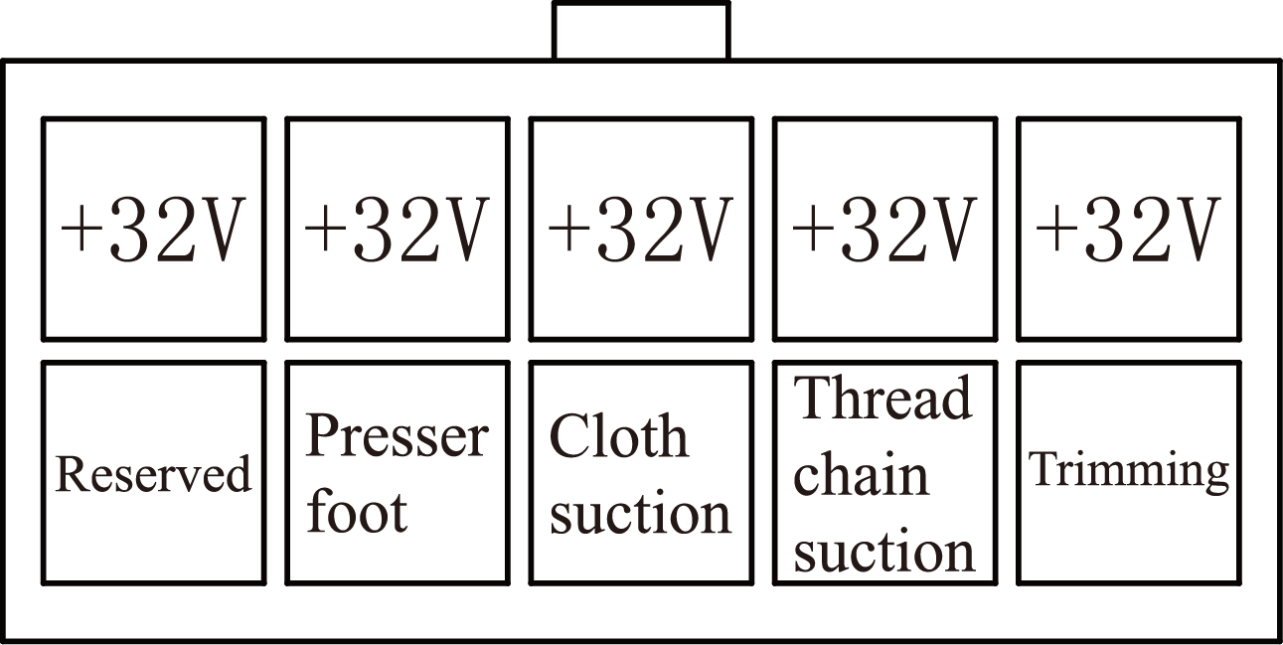
8P port description
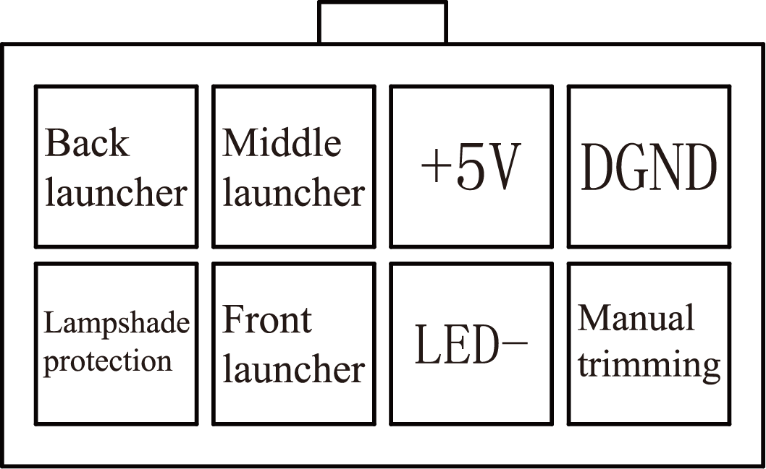
6P port description
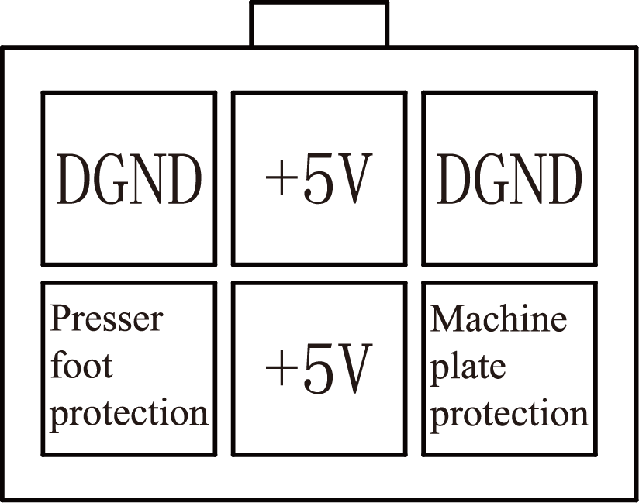
2P port S1 description (blue)
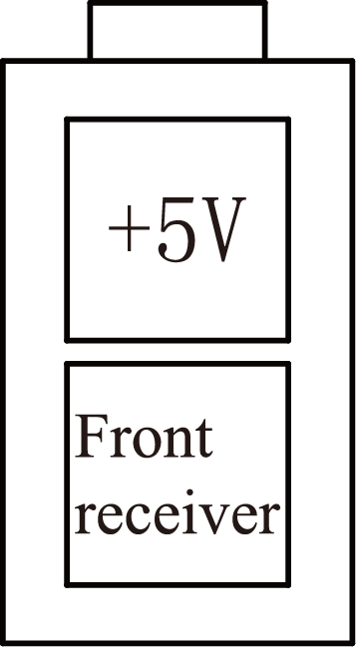
2P port S2 description (red)
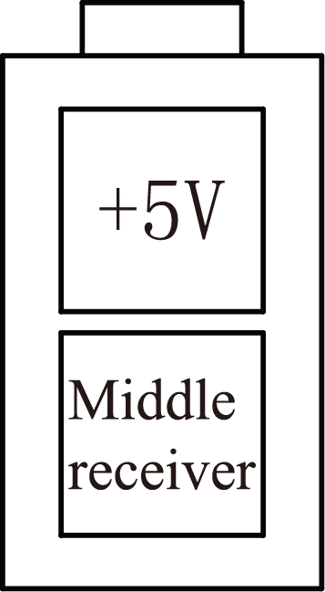
2P port S2 description (yellow)
