MCj03463170000[1]Safety Instruction

1. Users are required to read the operation manual completely and carefully before installation or operation.
2. The product should be installed and pre-operated by well-trained persons. All power supplies must be turned off during the installation work, remember not to operate with power on.
3. All the instruction marked with sign MCj03463170000[1] must be observed or executed; otherwise, bodily injuries might occur.
4. For perfect operation and safety, it is prohibited that using extension cable with multi-outlet for power connection.
5. When connecting the power cord, it must be determined that the operating voltage conforms to the rated voltage value specified in the product identification.
6. Don＇t operate in direct sun light，outdoors area and where the room temperature is over 45°C or below 0°C.
7. Please avoid operating near the heater at dew area or at the humidity below 10% or above 90%.
8. Don＇t operate in area with heavy dust, corrosive substance or volatile gas.
9. Avoid power cord being applied by heavy objects or excessive force, or over bend.
10. The earth wire of power cord must be connected to the system ground of the production plant by proper size of conductions and terminals. This connection should be fixed permanently.
11. All the moving portions must be prevented to be exposed by the parts provided.
12. Turing on the machine in the first time, operate the sewing machine at low speed and check the correct rotation direction.
13. Turn off the power before the following operation:

1. Connecting or disconnecting any connectors on the control box or motor.

2. Threading needle.

3. Raising the machine head.

4. Repairing or doing any mechanical adjustment.

5. Machines idling.

1. Repairs and high level maintenance work should only be carried out by electronic technicians with appropriate training.
2. All the spare parts for repair must be provided or approved by the manufacturer.
3. Don’t use any objects or force to hit or ram the product.

**Guarantee Time**

Warranty period of this product is 1 year dated from purchasing, or within 2 years from ex-factory date.

**Warranty Detail**

Any trouble found within warranty period under normal operation, it will be repaired free of charge. However, maintenance cost will be charged in the following cases even if within warranty period:

1. Inappropriate use, including: wrong connecting high voltage, wrong application, disassemble, repair, modification by incompetent personnel, or operation without the precaution, or operation out of its specification range, or inserting other objects or liquids into the product.

2. Damage by fire, Earth quake, lighting, wind, flood, salt corrosive, moisture, abnormal power voltage and any other damage cause by the natural disaster or by the inappropriate environments.

3. Dropping after purchasing or damage in transportation by customer himself or by customer’s shipping agency

* We make our best effort to test and manufacture the product for assuring the quality. However, it is possible that this product can be damaged due to external magnetic interference and electronic static or noise or unstable power source more than expected; therefore the grounding system of operate area must guarantee the good earth and it’s also recommended to install a failsafe device (Such as residual current breaker).

**1 Key Displays and Instructions and Operating Instructions**

**1.1 Key Description and Instructions**

|  |  |  |
| --- | --- | --- |
| Name | key | Indicate |
| Enter key |  | If click, lock / unlock. (Standby interface)  Click to check and save the content of the selected parameter number: After selecting the parameter number, press this key to check and modify the operation. After modifying the parameter value, press this key to exit and save the parameter. (Parameter interface) |
| F key |  | Click to enter or exit the user parameter setting interface.  In the shutdown state, press and hold the F key to boot into the technician parameter mode. |
| Parameter increase |  | If click, increase the parameter value. (Parameter interface)  If long press, the parameter value is continuously increased. (Parameter interface)  If click, increase the speed value. (Standby interface)  If long press, the speed value will be continuously increased. (Standby interface) |
| Parameter decrease |  | If click, decrease the parameter value. (Parameter interface)  If long press, the parameter value is continuously decreased. (Parameter interface)  If click, decrease the speed value. (Standby interface)  If long press, the speed value will be continuously decreased. (Standby interface) |

**1.2 Operating Instructions**

**1.2.1 Reset**

Press  and  at the same time, and turn on the machine. RST is displayed, press  to confirm, OFF is displayed, press  or  to change to ON, and press to confirm. After RST is displayed, the system will shut down and restart.

**1.2.2 Stepper Motor Debugging Mode**

In the shutdown state, adjust feed cam to the origin position. Long press and  to turn on the machine to display the main interface. Then long press  to enter the debugging mode, and N-01 is displayed.

**1.2.3 Lock and Unlock**

In the main interface short press  can switch the motor between locking and unlocking, starting the motor will be locked by default. When locked, the interface shown LOCK, the presser foot down and back pedal can be up presser foot, if step pedal the machine will not respond press  and  to modify the running speed. When unlocking, the interface will show a dynamic zero, if this time machine is at the origin position, half step pedal can down the presser foot, step pedal can start the machine; if it is not in the original position, step pedal can running the machine once, and the machine will stop at the original position.

**2 User Parameters & Technician Parameters**

**2.1 User Parameters**

| No. | Items | Range | Default | Description |
| --- | --- | --- | --- | --- |
| P01 | High speed running speed (spm) | 100-3600 | 3000 | High speed setting during sewing |
| P02 | Low speed running speed (spm) | 100-3600 | 2000 | Low speed setting during sewing |
| P03 | Trimming speed | 100-1000 | 800 | The speed of the machine when trimming |
| P04 | First stitch speed limit | 100-3600 | 800 |  |
| P05 | Second stitch speed limit | 100-3600 | 800 |  |
| P06 | Third stitch speed limit | 100-3600 | 2000 |  |
| P07 | Four stitch speed limit | 100-3600 | 2500 |  |
| P09 | Presser foot protection time | 1-600 | 5 |  |

**2.2 Technician Parameters**

| No. | Items | Range | Default | Description |
| --- | --- | --- | --- | --- |
| P13 | Stepper motor zero-point compensation | -100~100 | 0 | Fine-tuning the mechanical origin position of the stepper motor |
| P14 | Main shaft motor zero-point correction |  |  | Press  in the parameter adjustment interface, main shaft motor will automatically find the zero point, and press  to save after completion |
| P15 | The stitch number of stop machine protection | 1-990 | 30 | If feed cam can't sensing the stop signal, the machine needle should run how many stitches number can protection |
| P16 | Deceleration protection stitches number | 1-990 | 300 | If feed cam can't sensing deceleration signal, the machine needle should run how many stitches number can protection |
| P17 | Needles goes up automatically as power turned on | 0-1 | 1 | 0: OFF  1: After turning on the power, it will automatically find the upper positioning signal and stop |
| P18 | Up position adjustment | 1-2400 | 90 | Up position adjustment, the needle will advance stop when the value decreased, the needle will delay stop when the value increased. |
| P19 | Test run time (0.1s) | 1-250 | 20 | In the C test, set the on-time |
| P20 | Test stop time (0.1s) | 1-50 | 20 | In B and C tests, set the stop time |
| P21 | Testing A | ON/OFF | OFF | A test option, after setting, it will perform continuous running test at P01 speed |
| P22 | Testing B | ON/OFF | OFF | B test option, after setting, it will perform full functional test at P01 test speed |
| P23 | Testing C | ON/OFF | OFF | C test option, after setting, it will run without positioning at P01 test speed |
| P24 | Machine protection switch selection | 0-1 | 1 | 0: OFF  1: ON |
| P25 | Stop speed | 100-500 | 210 |  |
| P26 | Maximum speed | 100-3600 | 3600 |  |
| P27 | Up position quick adjustment | 0-2400 |  | Adjust up needle position, the displayed value will change with the position of the handwheel, press  to save the current position (value) as up needle position. |
| P28 | The highest of presser foot lift highness | 0-2400 | 500 | The Highness of presser foot lifting when starting  Note: The height value is the pulse value, 2400 means the stepper motor has rotated 360° |
| P29 | Presser foot speed | 20-400 | 200 |  |
| P30 | Lock machine presser foot switch | 0-1 | 0 | When start machine, under the lock state can back step presser foot. |
| P31 | Pedal step running position | 30-1000 | 700 | High speed start position |
| P32 | Pedal to mid-position | 30-1000 | 420 |  |
| P33 | Pedal half step position | 30-1000 | 600 | Low speed start position |
| P34 | Pedal back step position | 30-1000 | 130 |  |
| P35 | Aging running-in time | 0-9999 | 0 |  |
| P36 | End keyhole foot pressure state | 0-1 | 0 | 0: OFF  1: ON |

Note: the initial value of parameters is for reference only, and the actual value of parameters is subject to the real object.

**3 Error Code List**

|  |  |  |
| --- | --- | --- |
| Error Code | Problem | Measure |
| E01 | High voltage | 1. Whether the grid voltage is higher than AC260V.  2. If it is self-generated power supply, please reduce the generator power.  3. If it still does not work normally, please replace the control box and notify the after-sales service. |
| E02 | Low voltage | 1. Whether the grid voltage is lower than AC160V.  2. Reset.  3. If it still does not work normally, please replace the control box and notify the after-sales service. |
| E03 | CPU communication abnormal | 1. Turn off the system power and check whether the connection of the display screen is loose or disconnected, restart the system after returning it to normal.  2. Turn off the system power, remove the control box and only plug in the power cord to power on, whether alarm E05, if it still alarms E03, replace the control box and notify the after-sales service. |
| E05 | Pedal signal abnormal | 1. Check whether the pedal connector is loose or fall off, and restart the system after returning it to normal.  2. If it still does not work normally, please replace the control box or speed controller and notify the after-sales service. |
| E07 | Main shaft motor locked-rotor | 1. Turn off the power and check whether the handwheel can be turned smoothly (turn the handwheel by hand), if it cannot be turned, please check the machine;  2. Turn off the power, check whether the motor power connector is loose, plug it in and restart it;  3. Check whether the upper needle stop position is correct, if not, please adjust the upper positioning position;  4. If it still does not work normally, please replace the control box or main shaft motor and notify the after-sales service. |
| E10 | Electromagnet overcurrent | 1. Unplug the solenoid connector, if alarm E10, replace the control box and notify the after-sales service.  2. If there is no alarm after removing the solenoid connector, please plug it back in. |
| E11 | The positioning signal of main shaft motor encoder is abnormal | 1. Turn off the system power, check whether main shaft motor encoder connector is loose or fall off, restore it to normal and restart the system.  2. Check whether the motor zero point correction setting is correct; reset the motor zero point correction; Whether there is oil on the encoder code plate, please clean it if there is any;  3. If it still does not work normally, please replace the control box or main shaft motor and notify the after-sales service. |
| E14 | Main shaft motor encoder signal is abnormal | 1. Turn off the system power, check whether the main shaft motor encoder connector is loose or fall off, restore it to normal and restart the system.  2. Check whether the grating is installed correctly (whether the grating screws are tightened and whether the grating is in the center of the encoder).  3. Check whether there is oil on the encoder code plate, if there is, please clean it up, and restart the system after recovery.  4. If it still does not work normally, please replace the control box or main shaft motor and notify the after-sales service. |
| E15 | Main shaft motor drive overcurrent | 1. Please check whether the motor power cord has bad contact.  2. Please check whether the motor power cord is crushed.  3. Please replace the control box or main shaft motor and notify the after-sales service. |
| E17 | Machine overturned | 1. Turn off the system power and check if the machine is overturned.  2. Check whether the machine protection switch detection setting is correct.  3. If it still does not work normally, please replace the control box or panel and notify the after-sales service.  Press  to cancel the alarm once. |
| E19 | The feed cam deceleration sensor is not in the correct position | Check whether the position of feed cam is normal and whether the deceleration sensor is damaged. |
| E20 | The feed cam stopping sensor is not in the correct position | Check whether the position of feed cam is normal and whether the stop sensor is damaged. |
| E82 | Stepper motor overcurrent | 1. Turn off the system power and observe whether stepper motor is stuck. If it is stuck, remove the mechanical failure of the machine first. If it is normal, check whether connector of stepper motor is loose or fall off, restore it to normal and restart the system.  2. If it still does not work normally, please replace the control box or stepper motor and notify the after-sales service. |
| E84 | The positioning signal of stepper motor encoder is abnormal | 1. Turn off the system power and observe whether stepper motor is stuck. If it is stuck, remove the mechanical failure of the machine first. If it is normal, check whether the encoder connector of stepper motor is loose or fall off, and restart the system after returning it to normal.  2. Check whether the grating is installed correctly (whether the grating screws are fastened and whether the grating is in the center of the encoder);  3. Check if there is oil on the grating code plate, if so, please clean it up, and restart the system after restoration;  4. If it still does not work normally, please replace the control box or stepper motor and notify the after-sales service. |
| E85 | Stepper motor encoder signal is abnormal | 1. Turn off the power of the system, check whether the encoder connector of stepper motor is loose or fall off, restore it to normal and restart the system.  2. Check whether the grating is installed correctly (whether the grating screws  are fastened and whether the grating is in the center of the encoder);  3. Check if there is oil on the grating code plate, if so, please clean it up, and  restart the system after restoration;  4. If it still does not work normally, please replace the control box or stepper motor and notify the after-sales service. |
| E86 | Stepper motor failed to start | 1. Turn off the power of the system, check whether the power cord connector of stepper motor and the encoder connector are loose or fall off, restore them to normal and restart the system.  2. Check whether the grating is installed correctly (whether the grating screws are fastened and whether the grating is in the center of the encoder);  3. Check if there is oil on the grating code plate, if so, please clean it up, and  restart the system after restoration;  4. If it still does not work normally, please replace the control box or stepper motor and notify the after-sales service. |
| E87 | Stepper motor locked-rotor | 1. Turn off the system power and observe whether stepper motor is stuck. If it is stuck, remove the mechanical failure of the machine first. If it is normal, check whether the power cord connector of motor and the encoder connector are loose or fall off, restore them to normal and restart the system.  2. If it still does not work normally, please replace the control box or stepper motor and notify the after-sales service. |

**4 Port Diagram**

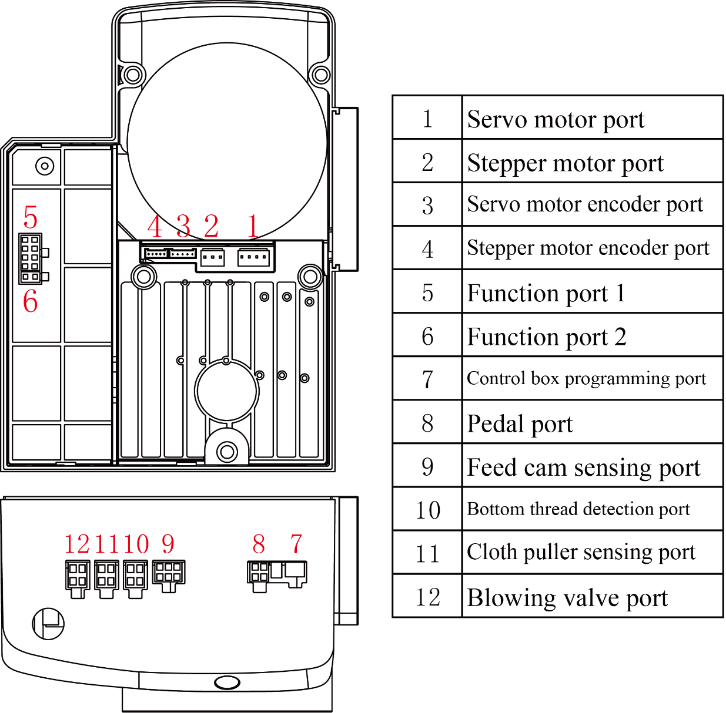

**Function port 1** **description**

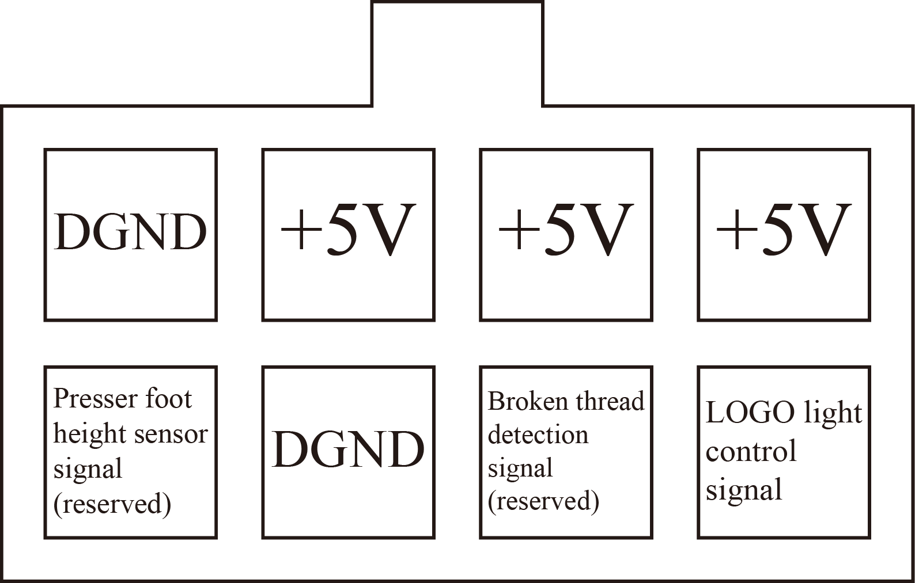

**Function port 2** **description (Reserved)**



**Feed cam sensing port description**

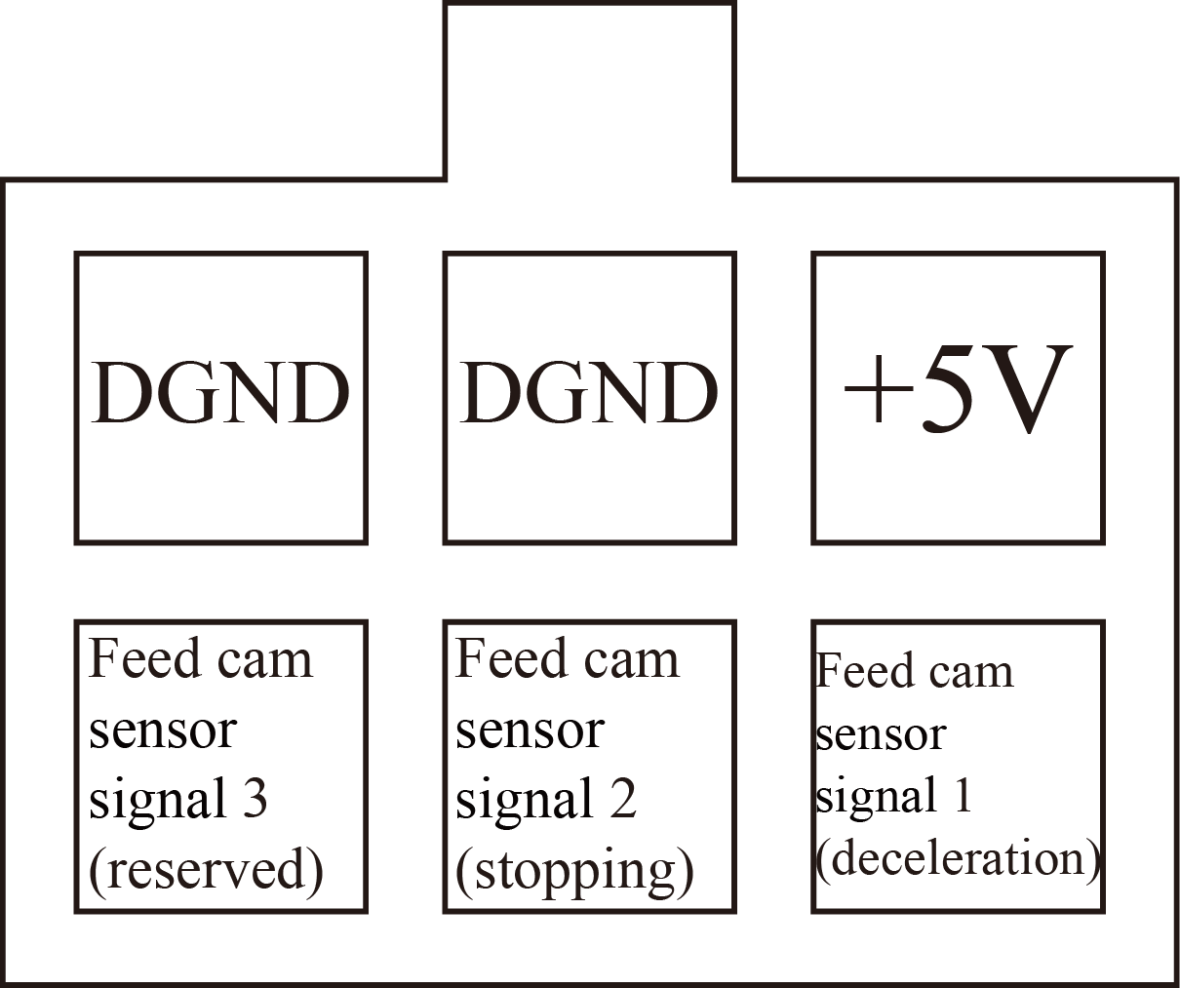

**Bottom thread detection port description (Red) (Reserved)**

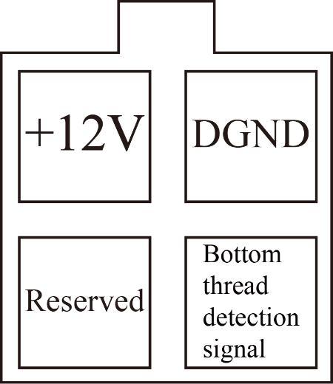

**Cloth puller sensing port description (Blue) (Reserved)**

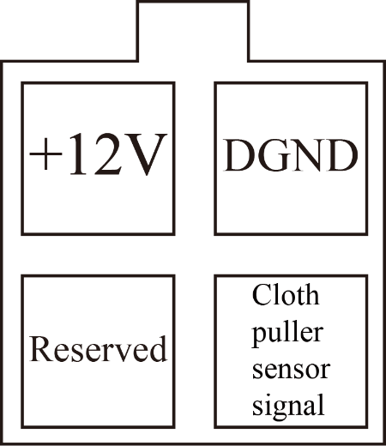

**Blowing valve port description (Orange) (Reserved)**

