MCj03463170000[1]Safety Instruction

1. Users are required to read the operation manual completely and carefully before installation or operation.
2. The product should be installed and pre-operated by well-trained persons. All power supplies must be turned off during the installation work, remember not to operate with power on.
3. All the instruction marked with sign MCj03463170000[1] must be observed or executed. Otherwise, bodily injuries might occur.
4. For perfect operation and safety, it is prohibited that using extension cable with multi-outlet for power connection.
5. When connecting the power cord, it must be determined that the operating voltage conforms to the rated voltage value specified in the product identification.
6. Don＇t operate in direct sun light，outdoors area and where the room temperature is over 45°C or below 0°C.
7. Please avoid operating near the heater at dew area or at the humidity below 10% or above 90%.
8. Don＇t operate in area with heavy dust, corrosive substance or volatile gas.
9. Avoid power cord being applied by heavy objects or excessive force, or over bend.
10. The earth wire of power cord must be connected to the system ground of the production plant by proper size of conductions and terminals. This connection should be fixed permanently.
11. All the moving portions must be prevented to be exposed by the parts provided.
12. Turing on the machine in the first time, operate the sewing machine at low speed and check the correct rotation direction.
13. Turn off the power before the following operation:

1. Connecting or disconnecting any connectors on the control box or motor.

2. Threading needle.

3. Raising the machine head.

4. Repairing or doing any mechanical adjustment.

5. Machines idling.

1. Repairs and high level maintenance work should only be carried out by electronic technicians with appropriate training.
2. All the spare parts for repair must be provided or approved by the manufacturer.
3. Don’t use any objects or force to hit or ram the product.

**Guarantee Time**

Warranty period of this product is 1 year dated from purchasing, or within 2 years from ex-factory date.

**Warranty Detail**

Any trouble found within warranty period under normal operation, it will be repaired free of charge. However, maintenance cost will be charged in the following cases even if within warranty period:

1. Inappropriate use, including: wrong connecting high voltage, wrong application, disassemble, repair, modification by incompetent personnel, or operation without the precaution, or operation out of its specification range, or inserting other objects or liquids into the product.

2. Damage by fire, Earth quake, lighting, wind, flood, salt corrosive, moisture, abnormal power voltage and any other damage cause by the natural disaster or by the inappropriate environments.

3. Dropping after purchasing or damage in transportation by customer himself or by customer’s shipping agency

* We make our best effort to test and manufacture the product for assuring the quality. However, it is possible that this product can be damaged due to external magnetic interference and electronic static or noise or unstable power source more than expected. Therefore the grounding system of operate area must guarantee the good earth and it’s also recommended to install a failsafe device (Such as residual current breaker).

**1 Button displays and operating instructions**

| Name | key | Indicate |
| --- | --- | --- |
| Function parameter edit |  | Press this key to enter or exit function parameter edit mode. |
| Setting parameter check and save |  | For the content of the selected parameters check and save: after select parameter press this key to check and modify operation, after modified parameter value press this key to exit and save the parameter. |
| Parameter increase / Speed increase |  | Increase the parameter / increase the sewing speed. |
| Parameter decrease / Speed decrease |  | Decrease the parameter / decrease the sewing speed. |
| LED brightness adjustment |  | Press this key to adjust LED brightness. |
| Slow launch setting |  | Set used or cancelled slow launch function. |
| Automatic presser foot lifting setting |  | If click, switch function off, automatic presser foot lifting after trimming, automatic presser foot lifting after pause, full function successively. |
| Auto-suction |  | Set used or cancelled auto-suction function. |
| Needle stop position selection |  | Set needle stop position. |
| Thread sweep key |  | Set used or cancelled thread sweeping function. |
| Upper knife trimming |  | Set used or cancelled upper knife trimming function. |
| Lower knife trimming |  | Set used or cancelled lower knife trimming and upper knife trimming function. |

**2 User parameter**

|  |  |  |  |  |
| --- | --- | --- | --- | --- |
| No. | Items | Range | Default | Description |
| P01 | Maximum sewing speed (rpm) | 100-9000 | 4500 | Maximum speed of machine sewing |
| P02 | Set accelerated curve (%) | 10-100 | 80 | Set the acceleration slope  The greater the slope value, the steeper the speed; the smaller the slope value, the slower the speed |
| P03 | Needle UP/ DOWN | UP/DN | UP | UP: Needle stops at up position  DN: Needle stops at down position |
| P07 | Soft start speed (rpm) | 200-1500 | 1000 |  |
| P08 | Stitch numbers for soft start (stitch) | 1-99 | 2 |  |
| P14 | Slow start function selection | ON/OFF | OFF |  |
| P21 | The position of the pedal for accelerating | 30-1000 | 500 |  |
| P22 | The position of the pedal for the stop | 30-1000 | 420 |  |
| P23 | The position of the pedal for presser foot lifting | 30-1000 | 280 |  |
| P24 | The position of the pedal for thread trimming | 30-1000 | 130 |  |
| P27-N06 | Automatic piece counting selection | 0-50 | 1 | 0: P41 item trimming counter does not automatically count  1-50: Counter thread trimming times |
| P29 | The strength of thread trimming stop | 1-45 | 20 |  |
| P37 | Upper knife thread trimming output function setting | 0-11 | 1 |  |
| P38 | lower knife thread trimming output function setting | ON/OFF | ON |  |
| P39 | [Automatic presser foot lifting](C:/Users/Administrator/AppData/Local/youdao/dict/Application/7.2.0.0703/resultui/dict/javascript:;) when pause function selection | UP/DN | DN | UP: ON  DN: OFF |
| P40 | [Automatic presser foot lifting](C:/Users/Administrator/AppData/Local/youdao/dict/Application/7.2.0.0703/resultui/dict/javascript:;) after trimming function selection | UP/DN | DN | UP: ON  DN: OFF |
| P41 | Counter display | 0-9999 |  | Display the quantity of finished sewing piece. Long-press “-” key to clear the count. |
| P42 | Information display |  |  | N01 The control system version number  N02 The panel version number  N03 Speed  N04 The pedal AD  N05 The mechanical angle(up position)  N06 The mechanical angle(down position)  N07 Bus bar voltage AD  N11 Stepping motor encoder count  N13 Stepping motor real-time current display (0.1A) |
| P43 | Direction of motor rotation | CCW/CW | CCW | CW: Clockwise  CCW: Counter clockwise |
| P44 | Brake strength during stopover | 1-45 | 15 |  |
| P45 | Periodic signal of suction output (%) | 1-80 | 80 |  |
| P48 | The minimum speed (positioning speed) (rpm) | 200-1000 | 500 | Adjust the minimum speed. |
| P52 | Delay the start of the motor to protect the lowering time of presser foot (ms) | 10-990 | 100 | Delay the start time, with automatic presser foot down. |
| P53 | Presser foot lifting function selection | 0-2 | 1 | 0: OFF  1: Back pedaling and half back pedaling with lifting presser foot  2: Half back pedaling without lifting presser foot, back pedaling with lifting presser foot |
| P55 | Upper thread trimming action time (ms) | 10-990 | 20 |  |
| P56 | Power on and positioning | 0-2 | 0 | 0: Always not to find the upper position  1: Always to find the upper0 position  2: If the motor is already in the upper position, no longer find the upper position |
| P57 | Presser foot protection time (s) | 1-120 | 10 | Forced to close after lifting the presser foot for a holding time. |
| P58 | Upper positioning adjustment | 0-1439 | 40 | Upper positioning adjustment, the needle will advance stop when the value decreased, the needle will delay stop when the value increased. |
| P59 | Down positioning adjustment | 0-1439 | 750 | Down positioning adjustment, the needle will advance stop when the value decreased, the needle will delay stop when the value increased. |
| P60 | Testing speed (rpm) | 100-6000 | 4000 | Setting testing speed. |
| P61 | Testing A | ON/OFF | OFF | Continuous running testing. |
| P62 | Testing B | ON/OFF | OFF | Start and stop testing with all functions. |
| P63 | Testing C | ON/OFF | OFF | Start and stop testing without all function. |
| P64 | Test run time | 1-250 | 50 |  |
| P65 | Test stop time | 1-250 | 50 |  |
| P70 | Model selection |  | 31 |  |
| P72 | Quick adjustment of upper positioning | 0-2399 |  | Adjust up needle position, the displayed value will change with the position of the handwheel, press "S" key to save the current position (value) as up needle position. |
| P73 | Quick adjustment of down positioning | 0-2399 |  | Adjust down needle position, the displayed value will change with the position of the handwheel, press "S" key to save the current position (value) as down needle position. |
| P76 | Lower thread trimming stroke | 0-800 | 550 | Distance from machine origin to end of thread trimming. |
| P77 | Height of press foot stroke | 0-1000 | 400 | The distance from the machine origin to the end point of the presser foot. |
| P78 | Acceleration of lower thread trimming | 1-30 | 10 |  |
| P79 | Retraction acceleration of lower thread trimming | 1-40 | 20 |  |
| P80 | Acceleration of presser foot lifting | 1-60 | 20 |  |
| P81 | Acceleration of presser foot lowering | 1-60 | 40 |  |
| P83 | Maximum operating speed of stepping motor | 300-1000 | 800 |  |
| P86 | Up and down needle position distance | 0-2399 | 1200 |  |
| P87 | Return delay of upper thread trimming (ms) | 10-990 | 15 |  |
| P89 | AC overvoltage setting | 500-1023 | 880 |  |
| P92 | Correct the electrical angle of motor |  |  | Reading the initial Angle of encoder, the factory default was set, please do not change the values (parameter value cannot be changed manually, random change it will result the control box and motor abnormal or damaged). |
| P93 | Half back pedal delay time (ms) | 10-900 | 150 |  |
| P100 | Lower knife test enable | 0-1 | 0 | 0: OFF  1: ON |
| P105 | Output selection of upper knife trimming port (classified by time sequence) | 0-2 | 0 | 0: Upper knife trimming  1: Blow  2: Thread sweeping |
| P107 | Suction action time (s) | 0-60 | 0 | 0: Long suction.  1-60: Automatically stop after exceeding the set time, and re-timing every time you step forward. |
| P108 | Suction function selection | 0-1 | 0 | 0: OFF  1: ON |
| P109 | Return time of lower knife trimming (ms) | 5-990 | 55 | The interval time before entering the upper thread trimming after finding the upper positioning. |
| P110 | Thread trimming / presser foot stepping motor zero point correction | -500~500 | 0 |  |
| P111 | Presser foot steady current (0.1A) | 7-25 | 10 |  |
| P112 | Current compensation for presser foot (0.1A) | 0-9 | 5 |  |
| P113 | Control type of presser foot holding stage | 0-1 | 0 | 0: Open loop  1: Closed loop |
| P119 | Electromagnet overcurrent protection | 0-1 | 1 | 0: No alarm, turn off the output.  1: Alarm and shutdown. |

Note: the initial value of parameters is for reference only, and the actual value of parameters is subject to the real object.

**3 Error code list**

|  |  |  |
| --- | --- | --- |
| Error Code | Problem description | Solutions |
| E01 | High voltage | Turn off the system power and check whether the power supply voltage is correct. (Or whether it exceeds the specified rated voltage).  If it’s correct, please replace the control box and notify the after-sales service. |
| E02 | Low voltage | Turn off the system power and check whether the power supply voltage is correct. (Or whether it is lower than the specified rated voltage).  If it’s correct, please replace the control box and notify the after-sales service. |
| E03 | CPU communication abnormal | Turn off the power of the system, check whether the connection of the control panel is loose or disconnected, restore it to normal and restart the system. If it still does not work, please replace the control box and notify the after-sales service. |
| E05 | Pedal signal abnormal | Turn off the system power, check whether the speed controller connector is loose or fall off, restore it to normal and restart the system. If it still does not work, please replace the speed controller and notify the after-sales service. |
| E07 | Motor locked-rotor | Turn the hand wheel of the machine head to see if it is stuck. If it is stuck, remove the mechanical failure first.  If the rotation is normal, check whether the motor encoder connector and motor power cord connector are loose. If there is any looseness, please correct it.  If the contact is good, check whether the power supply voltage is abnormal or the speed setting is too high. Please adjust if any.  If it still does not work, please replace the control box and notify the after-sales service. |
| E10 | Electromagnet overcurrent | Turn off the system power and check whether the solenoid (solenoid valve) is damaged or short-circuited. |
| E09  E11 | The positioning signal is abnormal | Turn off the system power, check whether the motor encoder interface is loose or fall off, restore it to normal and restart the system. If it still does not work normally, please replace the motor and notify the after-sales service. |
| E14 | Encoder signal is abnormal | Turn off the system power, check whether the motor encoder interface is loose or fall off, restore it to normal and restart the system. If it still does not work normally, please replace the motor and notify the after-sales service. |
| E15 | Power module abnormal overcurrent protection | Turn off the power to the system and turn it on again. If it still does not work, please replace the control box and notify the after-sales service. |
| E16 | The thread trimming switch is not in the correct position | Turn off the system power and check whether the thread trimming mechanism returns to the correct position. |
| E17 | The machine protection switch is not in the correct position | Turn off the system power, check whether the machine is opened, and whether the ball switch in the control box is displaced or damaged. |
| E20 | Motor failed to start (electrical angle error) | Turn off the system power, check whether the motor encoder interface and the motor power interface are loose or fall off, restore them to normal and restart the system. If it still does not work, please replace the control box and notify the after-sales service. |
| E92 | Thread trimming stepping motor overcurrent | Turn off the system power and observe whether the thread trimming (presser foot) stepping motor is stuck. If it is stuck, remove the mechanical failure of the machine head first. If it is normal, check if the thread trimming (presser foot) stepping motor interface is loose or fall off, restore it to normal and restart the system. If it still does not work, please replace the control box or the thread trimming (presser foot) stepping motor and notify the after-sales service. |
| E94 | Thread trimming (presser foot) stepping motor encoder positioning signal is abnormal | Turn off the system power and observe whether the thread trimming (presser foot) stepping motor is stuck. If it is stuck, remove the mechanical failure of the machine first. If it is normal, check whether the thread trimming (presser foot) stepping motor encoder interface is loose or falling off, and whether there is oil on the encoder code disk, if there is any oil, please clean it up, restore it to normal and restart the system. If it still does not work, please replace the control box or the thread trimming (presser foot) stepping motor and notify the after-sales service. |
| E95 | Thread trimming (presser foot) stepping motor encoder signal is abnormal | Turn off the system power, check whether the thread trimming (presser foot) stepping motor encoder interface is loose or fall off, restore it to normal and restart the system. If it still does not work, please replace the control box or the thread trimming (presser foot) stepping motor and notify the after-sales service. |
| E96 | Thread trimming (presser foot) stepping motor failed to start | Turn off the power of the system, check whether the thread trimming (presser foot) stepping motor power cord interface and encoder interface are loose or fall off, and restart the system after returning it to normal. If it still does not work properly, please replace the control box or the thread trimming (presser foot) stepping motor and notify the after-sales service |
| E97 | The stepping motor is blocked during thread trimming | Turn off the system power and observe whether the thread trimming stepping motor is stuck. If it is stuck, remove the mechanical failure of the machine first. If it is normal, check whether the thread trimming (presser foot) stepping motor power cord interface and encoder interface are loose or fall off, and restart the system after returning it to normal. If it still does not work normally, please replace the control box or trimming stepping motor and notify the after-sales service |
| E98 | The stepping motor is blocked during presser foot lifting | Turn off the system power and observe whether the presser foot stepping motor is stuck. If it is stuck, remove the mechanical failure of the machine first. If it is normal, check whether the thread trimming (presser foot) stepping motor power cord interface and encoder interface are loose or fall off, and restart the system after returning it to normal. If it still does not work, please replace the control box or presser foot stepping motor and notify the after-sales service |
| E99 | The stepping motor is over-current during presser foot lifting | Turn off the system power and observe whether the presser foot) stepping motor is stuck. If it is stuck, remove the mechanical failure of the machine first. If it is normal, check if the thread trimming (presser foot) stepping motor interface is loose or fall off, restore it to normal and restart the system. If it still does not work normally, please replace the control box or presser foot stepping motor and notify the after-sales service. |

**4 Port diagram**

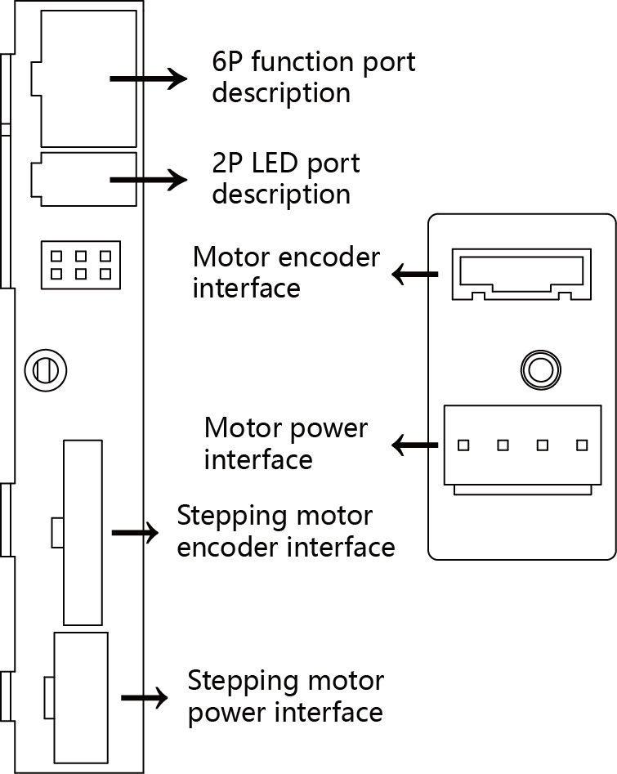

**2P port description**



**6P function port description**

