Safety Instruction
- Users are required to read the operation manual completely and carefully before installation or operation.
- All the instruction marked with sign must be observed or executed; otherwise, bodily injuries might occur.
- The product should be installed and pre-operated by well-trained persons.
- For perfect operation and safety, it is prohibited that using extension cable with multi-outlet for power connection.
- When connecting power supply cords to power sources, it is necessary to make sure that the power voltage matches the rated voltage indicated on the motor’s name plate.
- Don＇t operate in direct sun light，outdoors area and where the room temperature is over 45°C or below 5°C.
- Please avoid operating near the heater at dew area or at the humidity below 30% or above 95%.
- Don＇t operate in area with heavy dust, corrosive substance or volatile gas.
- Avoid power cord being applied by heavy objects or excessive force, or over bend.
- The earth wire of power cord must be connected to the system ground of the production plant by proper size of conductions and terminals. This connection should be fixed permanently.
- All the moving portions must be prevented to be exposed by the parts provided.
- Turing on the machine in the first time, operate the sewing machine at low speed and check the correct rotation direction.
- Turn off the power before the following operation：
a) Connecting or disconnecting any connectors on the control box or motor.
b) Threading needle.
c) Raising the machine head.
d) Repairing or doing any mechanical adjustment.
e) Machines idling.
- Repairs and high level maintenance work should only be carried out by electronic technicians with appropriate training.
- All the spare parts for repair must be provided or approved by the manufacturer.
- Don’t use any objects or force to hit or ram the product.
Guarantee Time
Warranty period of this product is 1 year dated from purchasing, or within 2 years from ex-factory date.
Warranty Detail
Any trouble found within warranty period under normal operation, it will be repaired free of charge. However, maintenance cost will be charged in the following cases even if within warranty period:
- Inappropriate use, including: wrong connecting high voltage, wrong application, disassemble, repair, modification by incompetent personnel, or operation without the precaution, or operation out of its specification range, or inserting other objects or liquids into the product.
- Damage by fire, Earth quake, lighting, wind, flood, salt corrosive, moisture, abnormal power voltage and any other damage cause by the natural disaster or by the inappropriate environments.
- Dropping after purchasing or damage in transportation by customer himself or by customer’s shipping agency
Note: We make our best effort to test and manufacture the product for assuring the quality. However, it is possible that this product can be damaged due to external magnetic interference and electronic static or noise or unstable power source more than expected; therefore the grounding system of operate area must guarantee the good earth and it’s also recommended to install a failsafe device. (Such as residual current breaker)

1 Key Description
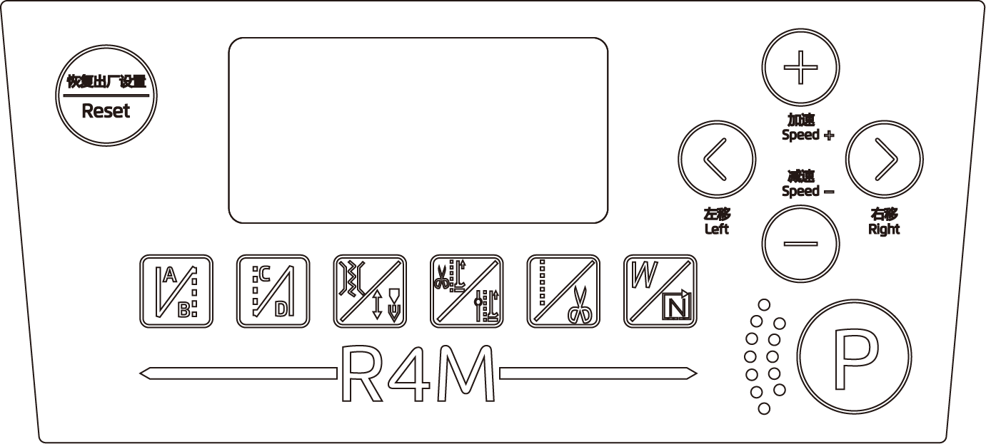

Name | Key | Indicate
Start back-tacking sewing |  | If click, switch starting back seam (A, B segment) 1 time, starting back seam (A, B segment) 2 times or turn off.
End back-tacking sewing |  | If click, switch ending back seam (C, D segment) 1 time, ending back seam (C, D segment) 2 times or turn off.
Clamping function setting / Needle stop position selection | 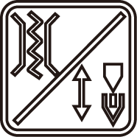 | If click, set used or cancelled clamping function.  If long-press, shift to the needle stop position (up position / down position).
Press foot lifting after trimming / Press foot lifting after pause |  | If click, set used or cancelled press foot lifting after trimming function.  If long-press, set used or cancelled press foot lifting after pause function.
Free sewing / Thread trimming |  | If click, shift to free sewing  If long-press, set used or cancelled thread trimming function.
Continuous Back Seam Shortcuts / Multi-section Set Needle Shortcuts |  | If click, shift to continuous back seam model.  If long-press, shift to multi-section set needle shortcuts.
Function parameter edit |  | Press this key can enter or exit the parameter setting interface.  Save and exit the selected parameter: Press this key after modifying the parameter value to exit and save the parameter.
Parameter increase |  | The main interface, if clicked, increase the speed of 50 rpm each time.  Parameter interface, if click, increase the parameter.
Parameter decrease |  | The main interface, if clicked, reduces the speed of 50 rpm each time.  Parameter interface, if click, decrease the parameter.
Left Selection Parameter Content |  | Left selection parameter content
Right Selection Parameter Content |  | Right selection parameter content
Restore Factory |  | Long-press can restore factory setting.
2 Auxiliary Function
2.1 Parameter adjustment
2.1.1 User parameter adjustment
Boot, long press  key enter to user parameter mode. Press  or  to change parameter item, remove cursor, the corresponding digit value is flashing, then press or  to modify this digit value, when the cursor is blinking at a numerical position, press key, the whole parameter value is flashing, save the parameter. Press key again to exit.
2.1.2 Technician parameter adjustment
In the off state, hold on key to turn on the machine (show P92) enter to technician parameter mode. Press or change parameter item, remove cursor, the corresponding digit value is flashing, then press or to modify this digit value, when the cursor is blinking at a numerical position, press key, the whole parameter value is flashing, save parameter. Press key again to exit.
2.2 Soft start
P14 adjustment in user parameters, the parameter is ON means open, the parameter is OFF means close (The default value).
2.3 Needle stop position function setting
In the off state, press and hold key to enter the technician parameter mode (the P27 parameter interface is displayed). Adjust the parameter to P72, manually rotate the handwheel to up position, the value displayed will change with the change of the wheel position. Press key to save the current position (value) as the up needle stop position and calculate down needle stop position automatically.

3 Parameter Definition
3.1 User Parameter (Turn on the machine and long-press P key to enter)
No. | Items | Range | Default | Description
P01 | Maximum sewing speed（rpm） | 200-5000 | 4000
P02 | Set accelerated curve（%） | 10-100 | 80 | The speed controller climbing slope setting.  The large of slope value = the fast of the speed.  The small of slope value = the slow of the speed.
P03 | Needle up/ down | UP/DN | DN | UP: Needle stops at up position  DN: Needle stops at down position
P04 | Start back-tacking speed（rpm） | 200-3200 | 1800
P05 | End back-tacking speed（rpm ） | 200-3200 | 1800
P06 | Bar-tacking speed（rpm） | 200-3200 | 1800
P07 | Soft start speed（rpm ） | 200-1500 | 400
P08 | Stitch numbers for soft start | 1-99 | 2
P09 | Automatic constant-stitch sewing speed（rpm） | 200-4000 | 3500 | Speed adjustment for automatic constant-stitch sewing
P10 | Automatic end back-tacking sewing | ON/OFF | ON | ON: After last seam of constant stitch sewing, it will automatic execute the End Back-Tacking sewing function. When turn on, the Stitch-Correction is invalid.  OFF: Automatic End Back-Tacking will not execute after last seam, but can be done by pedal manually.
P11 | Back-tacking Mode Selection | J/B | J | J: JUKI Mode (Press TB switch will activate reverse solenoid when either machine is stopped or running).  B: BROTHER Mode (Press TB switch will activate reverse solenoid only when machine is running).
P12 | Start back-tacking running mode Selection | A/M | A | A: Automatically perform actions  M: Could be arbitrarily stop and start
P13 | Ending mode of start back-tacking | CON/STP | CON | CON：Start Back-Tacking is completed automatically continued for next action.  STP：After the number of stitches is completed, stop automatically.
P14 | Slow start function selection | ON/OFF | OFF
P15 | Mending stitch mode | 0-5 | 2 | 0: Half stitch  1: One stitch  2: Continuous half stitch  3: Continuous one stitch  4: Continuous stitch, quick stop  5: Two stitches
P16 | Back-tacking speed limit | 0-3200 | 0 | When the parameter is 0, the speed limit function is OFF.
P18 | Start back-tacking compensation 1 | 0-200 | 144 | Stitch Balance for end back-tacking A section, 0~200 action gradually delay; the large value, the longer of the A section last stitch, and the shorter of the B section first stitch.
P19 | Start back-tacking compensation 2 | 0-200 | 155 | Stitch Balance for end back-tacking B section, 0~200 action gradually delay; the large value, the longer of the B section first stitch.
P21 | The position of the pedal for running | 30-1000 | 520
P22 | The position of the pedal for stopping | 30-1000 | 420
P23 | The position of the pedal for presser foot lifting | 30-1000 | 270
P24 | The position of the pedal for thread trimming | 30-500 | 130
P25 | End back-tacking compensation 3 | 0-200 | 144 | Stitch Balance for end back-tacking C section, 0~200 action gradually delay; the large value, the shorter of the C section first stitch.
P26 | End back-tacking compensation 4 | 0-200 | 155 | Stitch Balance for end back-tacking D section, 0~200 action gradually delay; the large value, the longer of the C section last stitch, and the shorter of the D section first stitch.
P28 | Bar-tacking running mode selection | A-M | A | A: Automatically perform actions  M: Could be arbitrarily stop and start
P29 | The strength of thread trimming stop | 1-45 | 30
P32 | Bar-tacking compensation 5 | 0-200 | 144 | Stitch Balance for start back-tacking A(C) section, 0~200 action gradually delay; the large value, the longer of the A(C) section last stitch; the shorter of the B (D) section first stitch.
P33 | Bar-tacking compensation 6 | 0-200 | 155 | Stitch Balance for start back-tacking B(D) section, 0~200 action gradually delay; the large value, the longer of the B(D) section last stitch; the shorter of the C section first stitch.
P34 | Constant-stitch sewing running mode selection | 0-1 | 1 | 1: Automatically perform actions  0: Could be arbitrarily stop and start
P35 | Piece count mode selection | 0-1 | 0 | 0: Manual piece counting  1: Automatic piece counting
P37 | Thread wiping function / Thread clamping function selection | 0-11 | 8 | 0: OFF  1: Thread wiping function  2-11: Thread clamping function, the higher the value, the stronger the action.
P38 | Automatic thread trimming function selection | ON/OFF | ON
P39 | Automatic presser foot lifting when pause function selection | UP/DN | DN | UP：ON  DN：OFF
P40 | Automatic presser foot lifting after trimming function selection | UP/DN | DN | UP：ON  DN：OFF
P41 | Counter display | 0-9999 |  | The number of sewing completed pieces is displayed; long press parameter decrease key to clear the count;
P42 | Information display | N01-N07 | N01 | N01 The control system version number I  N02 The panel version number  N03 Speed  N04 The pedal AD  N05 The mechanical angle(up position)  N06 The mechanical angle(down position)  N07 Busbar voltage AD
P43 | Direction of motor rotation | CCW/CW | CCW | CW: Clockwise  CCW: Counter Clockwise
P156 | Presser foot lifter operation duty cycle when start sewing (%) | 0-100 | 40
P159 | Start back-tacking presser foot output function switch | 0-1 | 1 | 0: OFF 1: ON
3.2 Technician Parameter (Hold P key to boot)
No. | Items | Range | Default | Description
P44 | The Rate of Normal Stop | 1-50 | 16 | Adjustment of efforts while machine stop.
P45 | Back-tacking Operation Duty Cycle (%) | 1-50 | 30 | Back-tacking operate in duty cycle to save electricity and protect the electromagnet from over-heat.
P46 | Motor stop with a reverse angle after trimming function | ON/OFF | OFF
P47 | Adjust the reverse angle when motor stop after trimming | 50-200 | 160 | After trimming, count from the up needle position and adjust the angle of the needle lift by reverse rotation.
P48 | Minimum speed (Positioning speed) (rpm) | 100-500 | 210 | Minimum speed limit adjustment
P49 | Thread trimming speed（rpm） | 100-500 | 250 | Adjust the motor speed during the tangent cycle
P50 | Foot lifter operation time to full output（ms） | 10-990 | 200
P51 | Presser foot lifter operation duty cycle (%) | 10-40 | 25 | Presser foot lifter operate in duty cycle to save electricity and protect the electromagnet from over-heat.
P52 | Delay the start of the motor to protect the lowering time of presser foot (ms) | 10-990 | 120 | Delay the start time, with automatic presser foot down.
P53 | Half back pedaling lifting presser foot function to cancel | ON/OFF | OFF | ON: Half back pedaling without lifting presser foot  OFF: Half back pedaling with lifting presser foot
P54 | Thread trimming action time（ms） | 10-990 | 200 | Completion of the thread trimming action required time.
P55 | Thread wiping / sweeping action time（ms） | 10-990 | 30 | Completion of the thread wiping / sweeping action required time.
P56 | Power on and positioning | 0-2 | 2 | 0: always not to find the up needle position  1: always to find the up needle position  2: If the motor is not into the up needle position, it will find the up needle position
P57 | Presser foot protection time (s) | 1-120 | 10 | Forced shutdown after hold time
P58 | Up needle position adjustment | 0-1799 | 460 | Up position adjustment, the needle will advance stop when the value decreased, the needle will delay stop when the value increased.
P59 | Down needle position adjustment | 0-1799 | 1360 | Down position adjustment, the needle will advance stop when the value decreased, the needle will delay stop when the value increased.
P60 | Testing speed（r/s ） | 100-4000 | 3500 | Setting testing speed.
P61 | Testing A | ON/OFF | OFF | After setting A, continuous running at the speed of 【P60.TV】
P62 | Testing B | ON/OFF | OFF | Option of Testing B, after setting press 【P60. TV】to set the speed execute the cycle of Start – Sewing –Stop - Trimming
P63 | Testing C | ON/OFF | OFF | Option of Testing C, after setting press【060.TV】to set the speed execute the cycle of Start – Sewing –Stop without positioning function
P64 | Running time of testing B and C | 1-250 | 30 | Setting running time of testing B and C
P65 | Stop time of testing B and C | 1-250 | 10 | Setting stop time of testing B and C
P66 | Machine protection switch selection | 0-2 | 1 | 0：Disable  1：Testing zero signal  2：Testing positive signal
P71 | Presser foot release operation duty cycle (%) | 0-40 | 2 | The buffer force of presser foot release operation.
P72 | Up needle position adjustment | 0-1799
P73 | Down needle position adjustment | 0-1799
P76 | Back-tacking operation time to full output（ms） | 10-990 | 250 | Back tacking start action, full output action times.
P78 | The start angle of thread clamping | 10-150 | 130 | Positioning angle when start clipping.
P79 | The stop angle of thread clamping | 160-359 | 320 | Positioning angle when finish clipping.
P80 | The start angle of thread trimming | 5-359 | 18 | Shear line infeed id angle setting(under defined as 0°)
P82 | The stop angle of thread trimming | 5-359 | 172 | Feeder back angle of thread trimming setting Down position as 0°.
P83 | The stopping distance | 10-100 | 30
P86 | The distance of up and down position | 100-1700 | 900
P88 | The thread sweep back times | 10-990 | 30
P89 | Alternating current (AC) over-voltage value setting | 500-1023 | 880
P92 | Correct the electrical angle of motor | 0-479 | 445 | Press the needle position key to read the initial angle of encoder, the factory default was set, please do not change the values (parameter value cannot be changed manually, random change it will result the control box and motor abnormal or damaged).
P99 | The Voice Switch | 0-2 | 1 | 0: OFF 1: Chinese 2: English
P108 | Boot up voice selection | 0-2 | 0 | 0: With welcome speech and key tone  1: With welcome speech but without key tone  2: With key tone but Without welcome speech
P110 | Trimming back time (ms) | 10-990 | 80 | Make sure the thread trimming device returns to its original position
P117 | The delay time of the presser foot release damping force (ms) | 0-990 | 12
P119 | Electromagnet over-current protection selection | 0-1 | 0 | 0: OFF 1: ON
P125 | The number of times for piecework trimming | 1-9 | 1 | Trimming number of times as setting number of times, piecework add 1.
P127 | Count stitches mode selection | 0-2 | 0 | 0: OFF  1: Count full reset but still running  2: Count full to stop machine
P136 | Start sewing first stitch speed limit | 0-1500 | 1500 | The default 0 is off
P137 | Start sewing second stitch speed limit | 0-2000 | 1500 | The default 0 is off
P138 | Start sewing third stitch speed limit | 0-2500 | 0 | The default 0 is off
P157 | The start angle of start sewing presser foot lifting | 1-359 | 1 | The start angle of start sewing presser foot lifting
P158 | The stop angle of start sewing presser foot lifting | 1-359 | 200 | The stop angle of start sewing presser foot lifting
Note: the initial value of parameters is for reference only, and the actual value of parameters is subject to the real object.

4 Error Code List
Error Code | Problem description | Measure
E01 | Over-voltage | Turn off the machine, check the power supply voltage. (Or whether exceed the rated voltage of use).  If there are still errors, please replace the control box and call for customer service.
E02 | Low-voltage | Turn off the machine, check the power supply voltage. (Or whether under the rated voltage of use).  If there are still errors, please replace the control box and call for customer service.
E03 | CPU communication error | Turn off the machine, please check if the operation panel in bad connection or is too loose. To get it right and turn on. If there are still errors, please replace the control box and call for customer service.
E05 | Pedal connection error | Turn off the machine, please check if the pedal in bad connection or is too loose. To get it right and turn on. If there are still errors, please replace the control box and call for customer service.
E07 | Motor locked-rotor error | Turn the machine handwheel, check if it is stuck. If it is stuck, you have to rule out the mechanical failure.  If turn normal, check if the encoder and motor in bad connection or is too loose. If yes, please correct.  If connection well, check if the power supply voltage is abnormal or sewing speed is too high. If yes, please adjust.  If there are still errors, please replace the control box and call for customer service.
E08 | Manual reverse feeding operation more than 15 seconds | Back-Tacking electromagnet response time is too long; you have only to restart the machine.  If there are still errors E-08 after restart the machine, check if the manual reverse feeding switch is damaged.
E10 | Solenoid over-current | Turn off the machine, please check the related circuit is shorted or damaged.
E09  E11 | Positioning signal error | Turn off the machine, please check if the encoder in bad connection or is too loose. To get it right and turn on. If there are still errors, please replace the control box and call for customer service.
E14 | Encoder error | Turn off the machine, please check if the encoder in bad connection or is too loose. To get it right and turn on. If there are still errors, please replace the control box and call for customer service.
E15 | Power supply module abnormal over-current | Turn off the machine, then turn on again. If there are still errors, please replace the control box and call for customer service.
E17 | Machine protection switch is not in the correct position | Turn off the machine, check if the machine is turn over, or the Mercury Switch is shifted or damaged.
E20 | Motor failed to start (Electrical angle error) | Turn off the machine, please check if the encoder and motor in bad connection or is too loose. To get it right and turn on. If there are still errors, please replace the control box and call for customer service.

5 Port Diagram
5.1 Port Description
Presser foot
Suction
口
8P function port

Speed control unit
口
14P function port

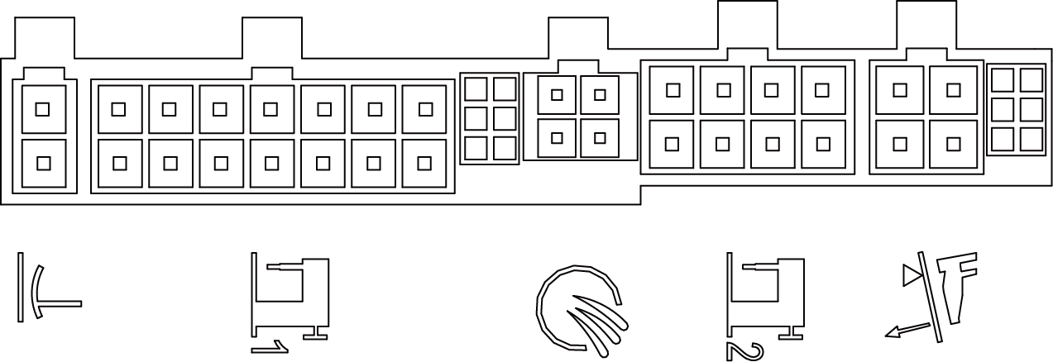
5.2 14P function port description
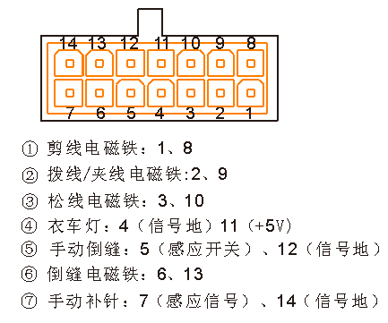
1. Back-tacking electromagnet: 7、14
2. Thread clamping (thread wiping) electromagnet: 3、10
3. Trimming electromagnet: 2、9
5.3 8P function port description
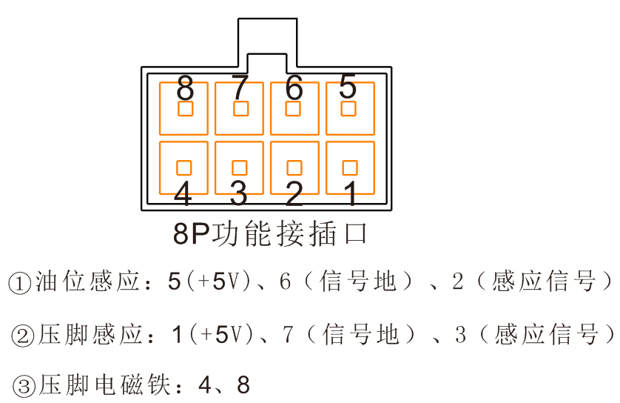
1. LED Light: 5、6（GND）
2. Fill needle key switch: 2、6(GND)
3. Manual Back-tacking switch: 1、6(GND)

