**1 Boot Interface**

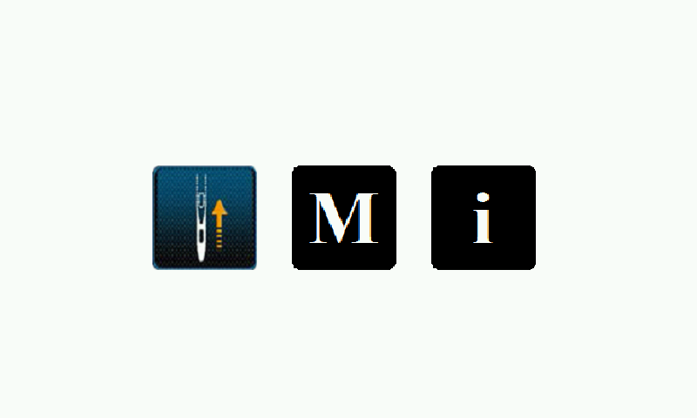

Boot screen icon description:

 Sewing confirmation key. Click this key, the spindle motor and the pendulum motor will find the origin point, and the system will enter the sewing mode.

 Factory setting key. Press and hold this key, the system will enter the factory setting mode. (It will state individually).

 System information key. Long press this key will enter to the system information mode. The information mode includes the system software version for the panel and control box, and the software upgrade function for the panel and control box. Enter to this mode, the system cannot return. If you need to enter other modes, please turn off the power and restart the machine.

**2 Sewing Interface**

The sewing interface is divided into three categories: free sewing, overlapping sewing, and programmed sewing.

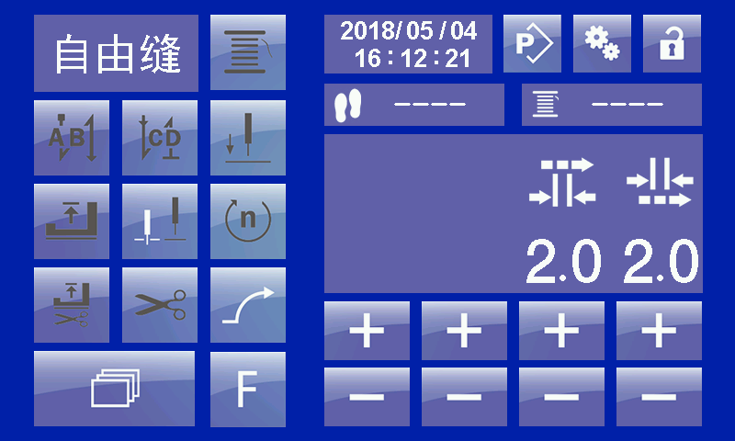

Figure 1: Free sewing interface

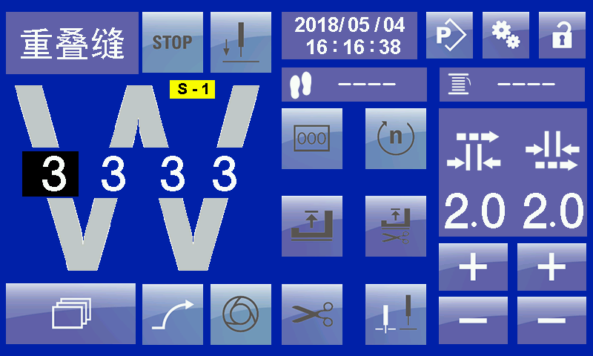

Figure 2: Overlapping sewing interface

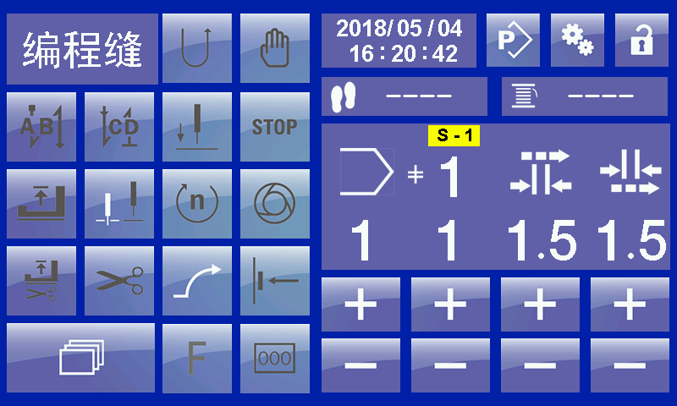

Figure 3: Programmed sewing interface

**2.1 Key Description**

 

Start back-tacking, the white font icon indicates that this function is activated and the dark gray font icon indicates that this function is invalid.

 

End back-tacking, the white font icon indicates that this function is activated and the dark gray font icon indicates that this function is invalid.

 

The position of the needle when stop. The previous icon indicates that the needle is under the cloth after stop, and the latter icon indicates that the needle is on the cloth after stop.

 

The presser foot is lift or not when stop the machine. the white font icon indicates that this function is activated and the dark gray font icon indicates that this function is invalid.

 

The presser foot is lift or not after trimming stop machine. the white font icon indicates that this function is activated and the dark gray font icon indicates that this function is invalid. When activated, the presser foot position is in the upper position after stop trimming. When not activated, the presser foot position is in the lower position. The default state is not activated.

 

Trimming function. The white font icon indicates that this function is activated and the dark gray font icon indicates that this function is invalid. When activated, the current sewing section can be trimming. If not activated, the current sewing section cannot be trimming.

 

Rotational speed setting. The white font icon indicates that this function is activated and the dark gray font icon indicates that this function is invalid. When activated, click the "scroll key”, find the speed setting item. Press corresponding the "+" and "-" keys, it can adjust speed. Under the free sewing mode, you can change speed of "start back-tacking", "end back-tacking" and the current segment. Under the overlapping sewing and programmed sewing it just can change current segment speed.

 

Back-tacking setting. The white font icon indicates that this function is activated and the dark gray font icon indicates that this function is invalid. This key is used for programming sewing and pattern editing. In the programming sewing, it is used for instantly change the current sewing segment direction. In the pattern editing, it used for setting current programming segment sewing direction, the reverse direction is activated, the normal sewing direction is not activated.

 

Needle position setting. The white font icon indicates that this function is activated and the dark gray font icon indicates that this function is invalid. When it need to use needle position function, please setting the spindle parameter P12 “Needle position function” setting value to 1, turn on this function. Then activate the needle position setting key. Needle position angle setting ref to “needle position setting method”, user manual will describe on subsequent chapter.

 

Knee-control switch function. Under the overlapping sewing and programmed sewing after turn on this function, use knee-control switch can shift sewing segment in turn in the edited pattern.

 

Back-tacking temporary cancel function. After setting start back-tacking or end back-tacking in current sewing pattern, if current temporary no need to back-tacking then can active this key, and sewing next backing-tacking can cancel. And end back-tacking also can effective.

 

The program interrupt key. This key is used in the programmed sewing state. Under the programmed sewing state press this key, the current sewing program interruption it will not counted, after that tread the pedal machine will be free sewing according to the data of the sewing segment at the time of interruption. Cancel activation, the program will continue.

 

Under the free sewing mode activate this key used for coiling bottom thread, at this time the upper and lower rollers not action.

 

Under the programming sewing activate this key, it will automatic stop machine after sewing is completed for current segment. If not activated, then the editing pattern will continuously sewing until the end of program.

 

Under the programmed sewing mode activated this key, then tread the pedal machine will be automatic sewing complete pattern.

 

Under the programmed mode activated this key, and use the “scroll key” find the corresponding setting item, then can change the current sewing stitches for sewing segment.

 

Turn on the soft start function then can activated this key.



Free sewing, overlapping sewing and programmed sewing shift key. At the end of program or at the end of force trimming state, press this key can shift free sewing, overlapping sewing and programmed sewing mode.



Scroll key. Under the sewing mode can use this key to shift between different setting items. But the prerequisite is setting item need to be activated.

功能。Function



Press this key on correspond position, parameter plus.



Press this key in correspond position, parameter minus.



Long press this key, it will enter to pattern editing mode. See the following section for detailed operation.



Long press this key, it will enter to parameter setting mode. See the following section for detailed operation.

 

Lock and unlock key. The previous icon indicates that the touch screen is locked. At this time, other keys on the touch screen are invalid except the unlock key, after clicking the unlock key, other keys on the touch screen resume function. The latter key icon indicates the unlock key, and in this state, the icons displayed on the LCD panel are all available. After manually clicking the unlock key, the touch screen will be locked. Or the automatic lock time is set in the parameter setting. After the time value is reached, the system will automatically lock.



Record stitches number and setting key. After counting stitches function turn on, this icon will display initial value. Setting method see following chapter.



Bottom thread display and setting key. This icon will display the remaining bottom thread when the bottom thread counter function is turned on. Setting method see the following chapter.



Return key.

**2.2 Icon description**



Upper roller icon



Lower roller icon



This icon corresponding number indicates current pattern no.



This icon corresponding number indicates current sewing speed.



This icon corresponding number indicates current sewing stitches.



This icon number indicates current sewing segment.   
**3** **Basic Operation**

**3.1 Free Sewing**

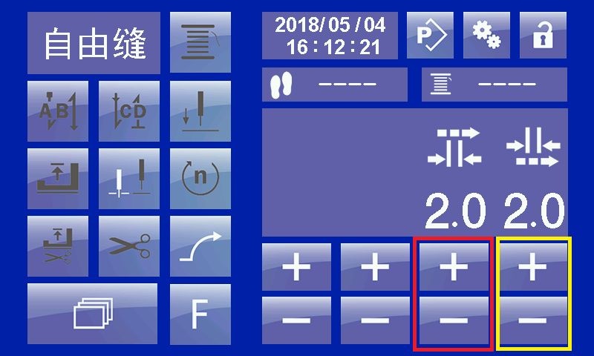

Figure 4: Free sewing interface-roller value setting

**3.1.1 Adjustment of Roller Value**

As shown in the figure above, click or long press "+" in this interface, and the "-" key will change the current value of up and down rollers. The red box indicates the "up roller" adjustment key. The yellow box indicates the scroll wheel adjustment key. The interval between the upper and lower roller values shall not exceed 1.0 mm.

**3.1.2 Start Back-tacking Setting**

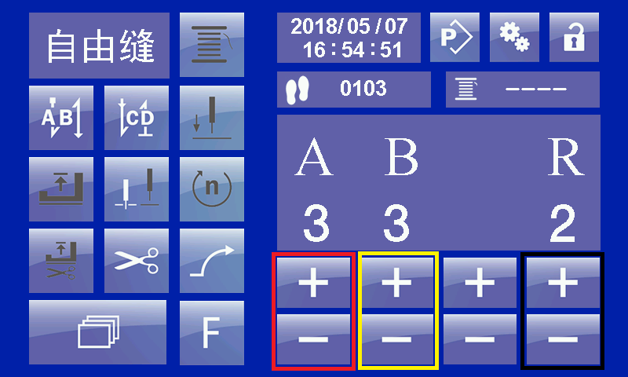

Figure 5: Free sewing screen- start back-tacking setting

If you need to set up start back-tacking, activate the back-tacking key first. Then, click the scroll key，shift settings interface, as shown above. Red box set "A" section, yellow box set "B" section, black box, set repeat number "R". R value is 2 and 4, when 2 indicates sewing AB, and as 4, it means sewing ABAB.

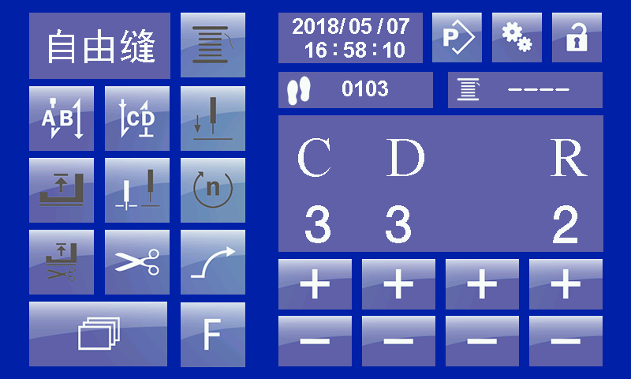

Figure 6: Free sewing interface- End back-tacking setting

If need to set end back-tacking, first to activated back-tacking key. and then click scroll key , shift setting interface. Setting method same as the start back-tacking.

**3.1.3 Speed Setting**

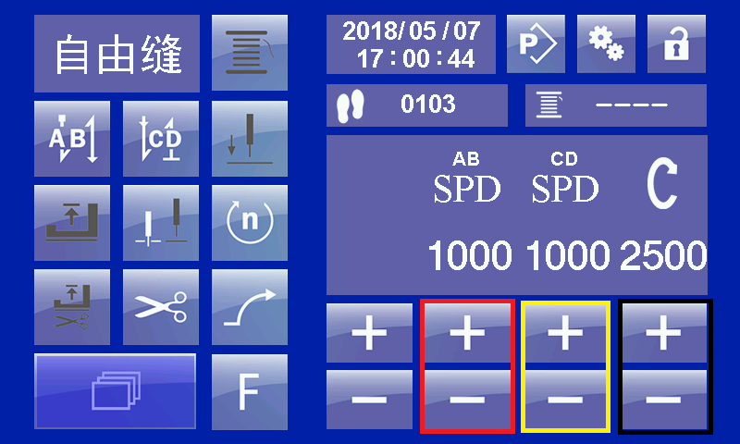

Figure 7: Free sewing interface - speed setting

If need to setting speed, first to activated speed setting key. And then click scroll key  shift setting interface. Red box can setting start back-tacking speed, yellow box can setting end back-tacking speed, black box can setting speed of free sewing segment.

**3.1.4 Needle Position Setting**

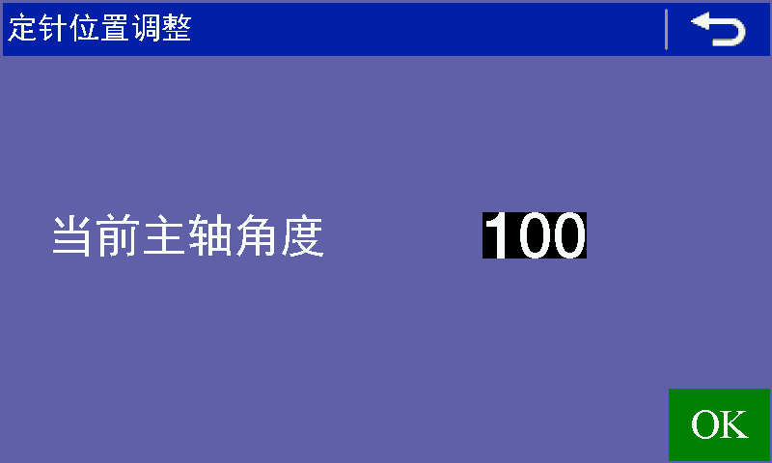

Figure 8: Free sewing interface - needle position angle setting

If need to use needle position function. First to setting the spindle parameter P12 “needle position function” setting as 1, turn on this function. And then activated needle position setting key. Long press this key to enter needle position angle setting interface. As shown in figure 8. Interface current display spindle shaft position, use the hand-wheel to turn the needle bar to requirement position, press “OK” key to save the current setting value, and then press return key  to turn back.

**3.2 Overlapping Sewing**

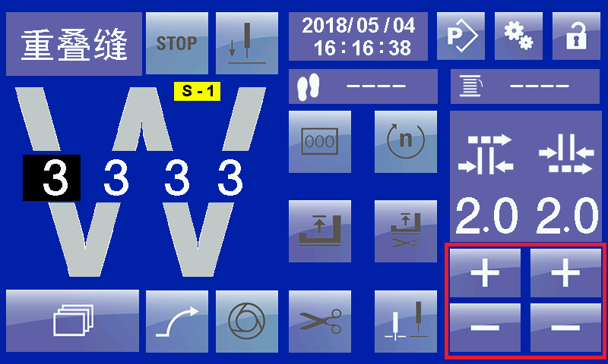

Figure 9: Overlapping sewing interface - scroll value setting

If you require to modify the data of one section, then click position of corresponding segment stitches number. At this time corresponding position display black background white word that indicates current segment is selected. After selected one section, the relevant keys and data in this page is belong current segment. As shown in the above figure, “A” segment is selected, at this time right side area display the upper and lower scroll value for “A” segment. Through red box “+”, “-” key, it can add or reduce the scroll value. Stitches and speed setting same as the free sewing, all need to activate the corresponding key then press scroll key to modify.

After  key is activated, the system stops automatically after complete each segment sewing. Return the pedal to a neutral position and tread sewing position then can continue sewing next segment. If no need then set this key as invalid state.

After  key is activated, tread the pedal, system will automatically sewing all pattern till to finished. If no need the to set this key as invalid state .

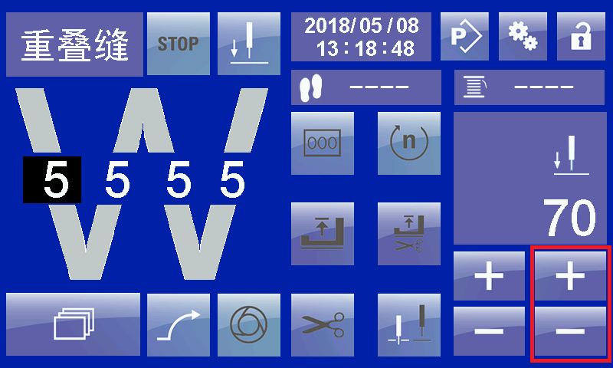

Figure 10: Overlapping sewing interface- needle position setting

If need to use needle position function in the overlapping sewing, please activated  key. Press scroll key  shift to needle position setting page, use “+”, “-” key modify to require angle value. As require needle position value can through free sewing needle position angle setting page, by turn over hand-wheel, obverse current spindle shaft position to confirmation.

**Noted: each section of the overlapping sewing can be set separately, including speed, stitches count, trimming, needle position, and whether trimming or not. Please confirm the pattern of sewing method and setting is same as your requirement or not before programming, otherwise it will make different sewing effects.**

**3.2 Programmed Sewing**

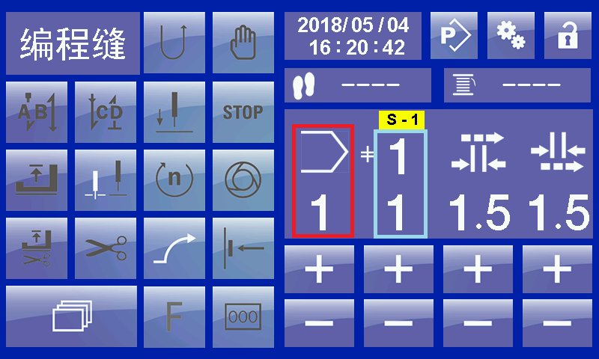

Figure 11: Programmed sewing interface - description

As shown in the above figure, in the programmed sewing interface red box indicates the current code of pattern. Right side blue box at the top of number indicates current pattern total segment. The below number indicates segment no. of currently displayed on the LCD. Under the programmed sewing finished, it can use in the red box"+" and "-" keys to select different patterns stored in the system. If the pattern selected has more than one segment, it can be selected by "+" and "-" in the blue box. Under the sewing interface, you can modify all the data except adding section, deleting section and circular sewing function. After modification, the parameters will be available.

It need to note the front two pattern in the programmed sewing, the pattern 1 and pattern 2 are fixed pattern can’t to delete. Each pattern can add 3 segment. Each segment sewing is free sewing mode, after added multi-segment, it can through sewing machine head key, knee-control switch and LCD panel to shift between multi-segments. Please activated  key if you need to use sewing machine head keys or knee-control switch to shift between segments, otherwise the system will not perform shift action. Multi-segment can setting different stitches number. The following description is use LCD panel to shift different segment method. Such as below figure is no.1 pattern has been added as 3 segment.

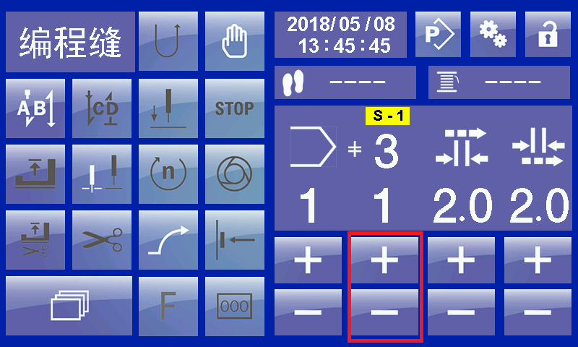

Figure 12: Programmed sewing interface - multi-segment shift

Use the LCD panel to shift different segment, at first need to activated  key, then use “+”,”-” key in the red box to select require sewing segment.

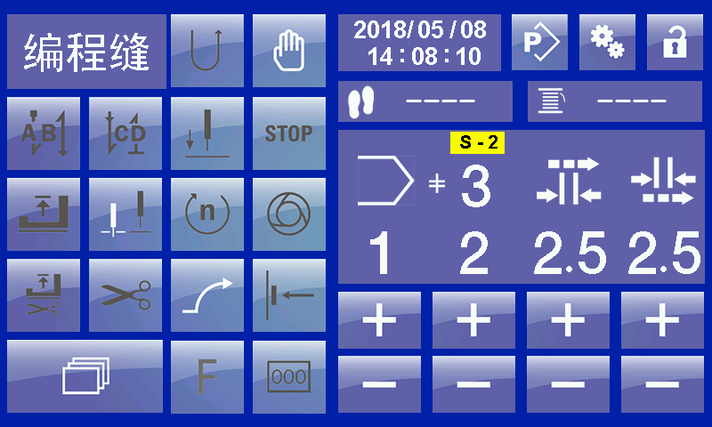

Figure 13: Programmed sewing interface- multi-segment shift

As shown in above figure is shift to the second segment interface, segment no is display 2nd segment, after  number and selected segment number is same number 2. Only in this case, the segment shift succeed. If not activated break key , after selected segment number, after  number is different with segment number, at this time haven’t shift the pattern data, just shift segment data page, sewing information not transmitted to control box .

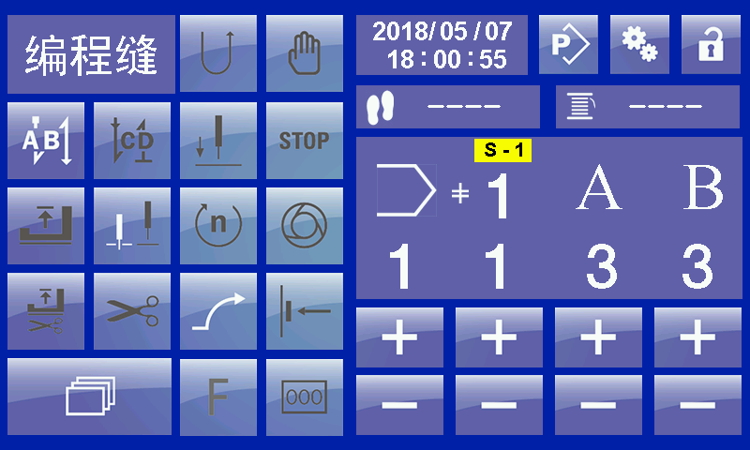

Figure 14: Programmed sewing interface- setting start back-tacking

On the programmed sewing, start back-tacking, end back-tacking setting method is similar as free sewing. The different is under programmed modem, it can’t modify speed and repeat times for start back-tacking and end back-tacking. If modified this information need to enter program editing mode select corresponding pattern to edit.

**4 Parameter Setting**

Long press  key, enter to parameter setting interface.

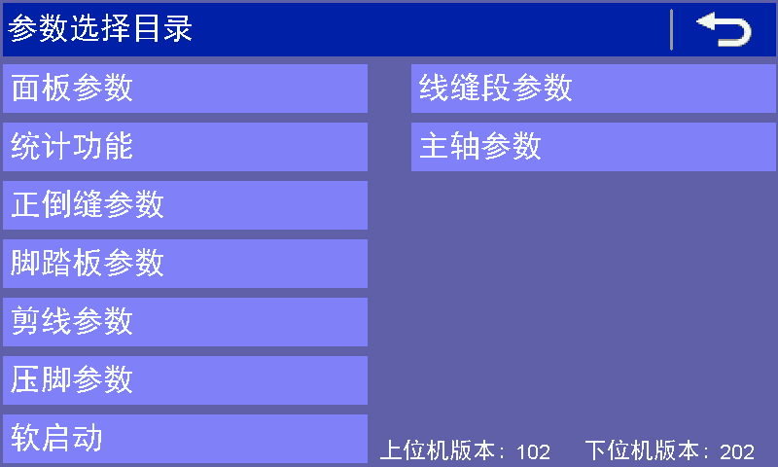

Figure 15: Parameter selection interface

Parameter selection interface bottom right display software version information of operation panel and control box

Take the 1st parameter as an example: after click “panel parameter”, enter to panel parameter setting interface.

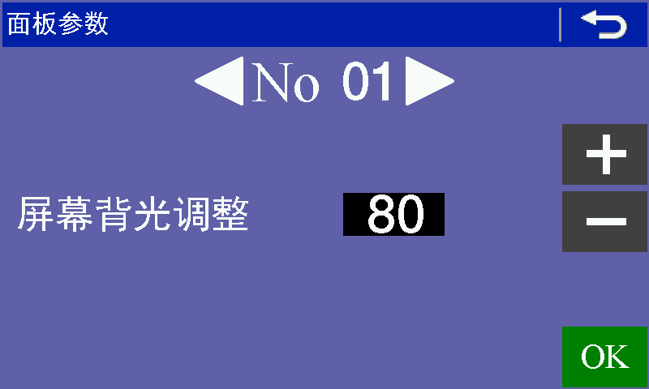

Figure 16: Parameter setting interface

As shown above figure,  click white key for turn left or turn right, interface will turn to previous or latter parameter setting interface, at the same time after No. Number will be change accordingly. After select the parameter item which want to modify, use right side “+” “-” key to modify the parameter value. After modified, click “OK” key to save. If not click “OK” key then to shift parameter item or exit setting, the parameter will not to save. Other parameter setting method same as this.

**5 Program Editing**

After long press  key, it will enter program editing catalogue page.

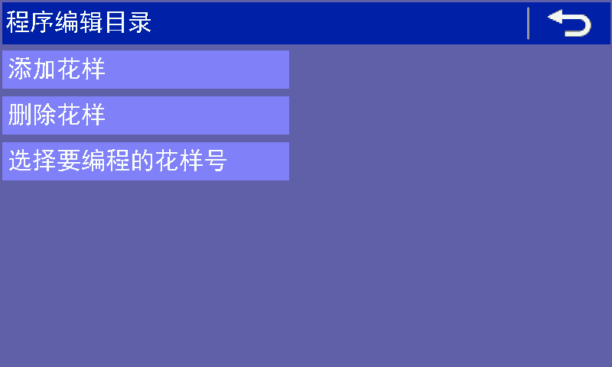

Figure 17: Program editing catalogue

**5.1 Added Pattern**

Click “added pattern” item, it display interface.

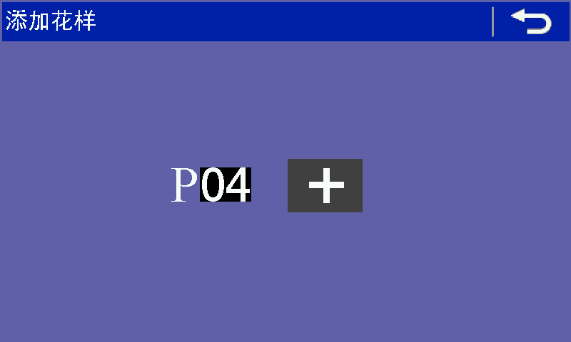

Figure 18: Added pattern

As shown above figure, in the P04 the 04 indicates it will add pattern code, click right side “+” key will added 4th pattern. After complete added, waiting add pattern number will automatic add 1 to became next waiting for add pattern, if no need to continue add then press return key to back.

**5.2 Delete Pattern**

Click “delete pattern” item, display interface.

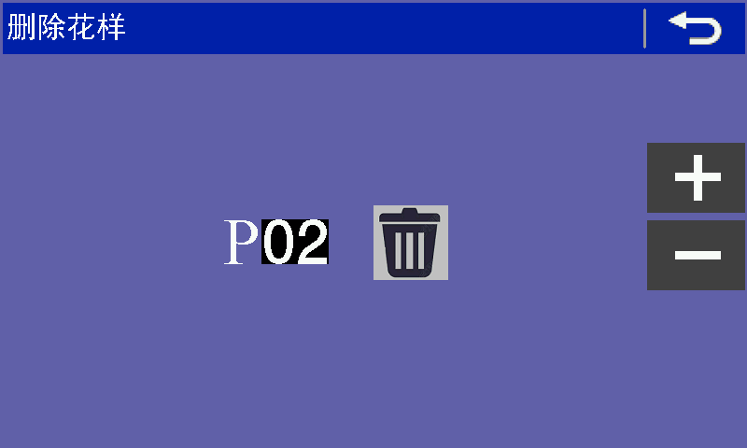 Figure 19: Delete pattern

Use right “+”, “-”key to select waiting delete pattern. Then press  key to delete pattern. No.1 and No.2 pattern can’t delete.

**5.3 Pattern Editing**

Click “select will need to editing pattern no” item, display interface.

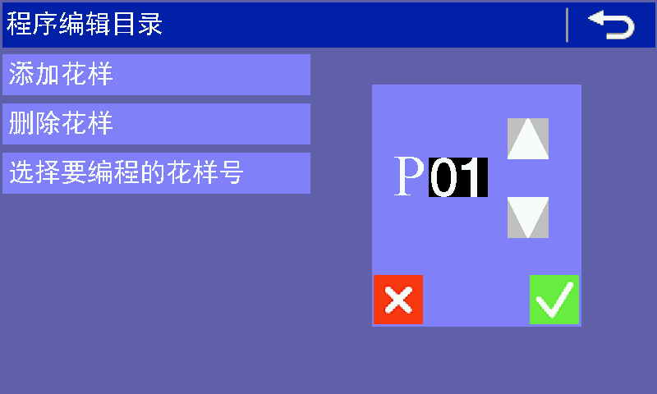

Figure 20: Select waiting editing pattern

Press   key to select need to editing pattern number. After select press  key, to enter editing interface.

**5.3.1 Editing Method**

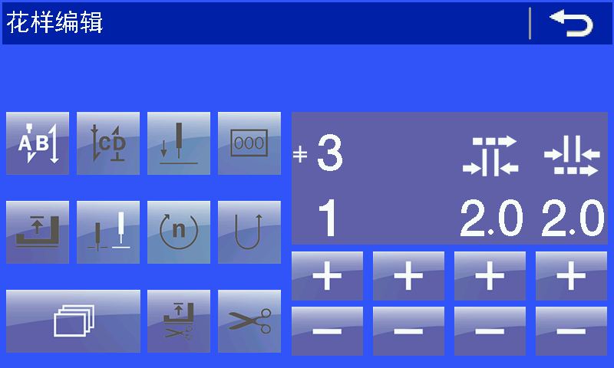

Figure 21: Pattern editing method

Pattern editing method, it is similar with previous chapter introduction setting method in the sewing interface. At first it need to consider the pattern require how many segment. If more than 1 segment, then need to add the segment. At this time click  key to shift segment added, delete page.

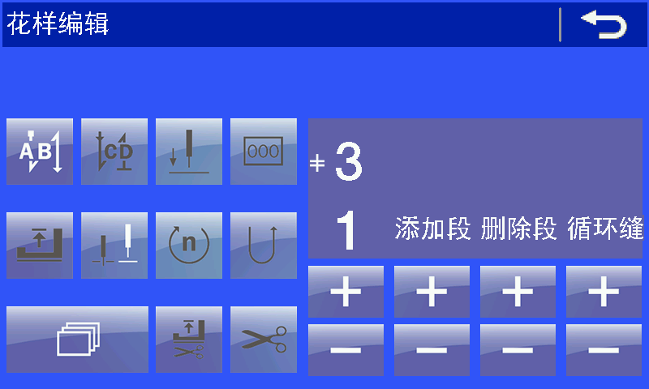

Figure 22: Adding delete segment

Press “+”, “-” key white font below of the “add segment”, delete segment. Press “+”, “-” key white font below of the “cycle sewing”, the pattern setting as the cycle sewing mode. **Noted: only after the segment have been set then can setting cycle sewing.**

After the segment have been set, press left “+”，“-”key below of the segment select need to editing segment.

For example: editing for one pattern of 3 segment, the one fist segment 6 stitches, the stitches length 3mm, start have start back-tacking, segment speed 2000. The second segment 8 stitches, the stitches length 3.5mm, segment speed 2100. The third segment 10 stitches, stitches length 4.0mm, segment speed 2200. Trimming and foot presser lift after end back-tacking.

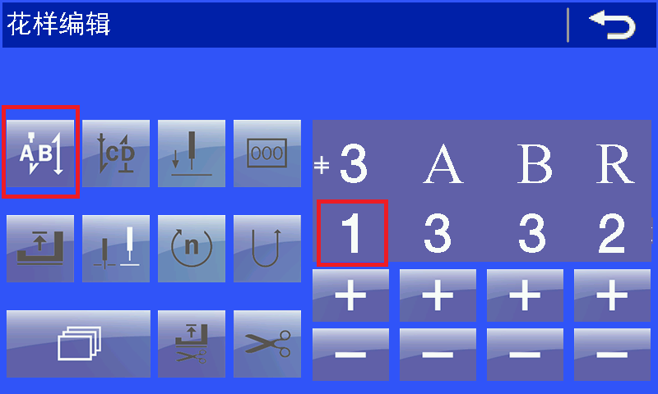

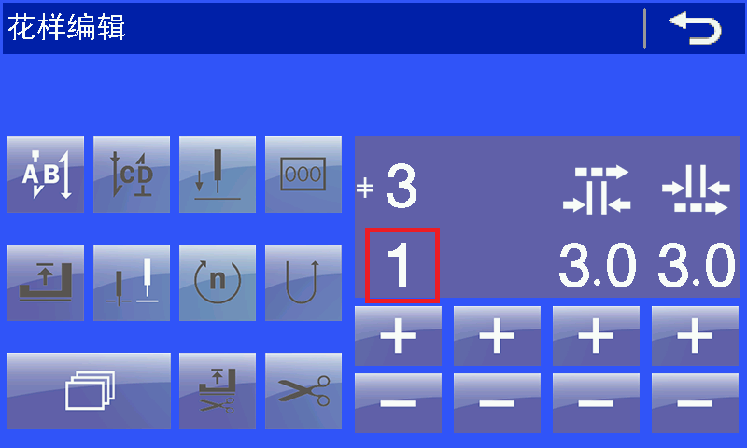

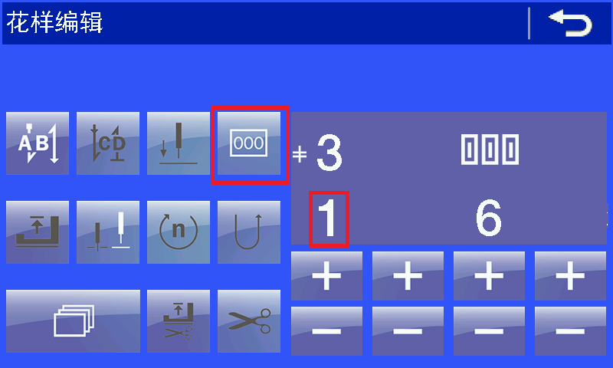

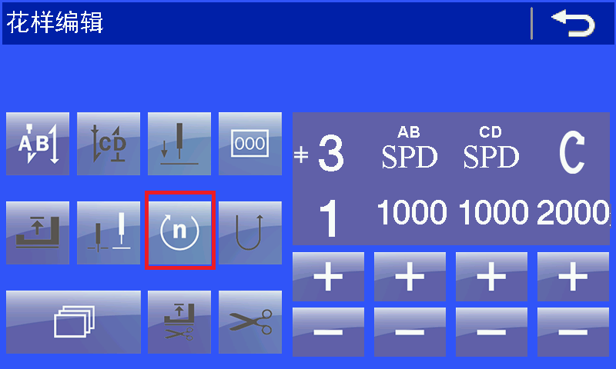

Shift between each setting use scroll key. The 2nd segment and 3rd segment setting method is same as 1st segment. You just have to change the segment number. As following picture shows:

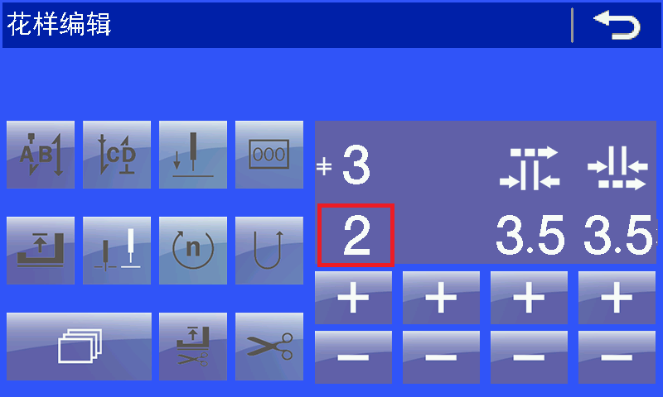

It need to save pattern after pattern editing setting.

Error Code List

**1** Control box error code

3100 Software unauthorized

3101 Parameter out of range

Reinitialize parameter

3110 Pedal setting error / or pedal malfunction

Pedal AD value is not correct

3111 Encoder or datum point sensor malfunction or motor malfunction

Please check the spindle shaft is stuck or not, or encoder malfunction.

3112 Date error

Date process error, reset sewing parameter

3113 Zero-position sensor error

Please check the spindle shaft is stuck or not, or encoder malfunction.

3114 Sewing machine head open

Machine head is turn over or machine head sensor angle of inclination malfunction

3118 Solenoid malfunction

Please check the solenoid is short-circuit or not.

3119 Spindle shaft abnormal

Spindle shaft stuck or encoder abnormal

3120 Pendulum motor abnormal

Pendulum stuck or other caused can’t rotate

3121 Communication malfunction

It not received the panel return data

3122 Communicate data verification error

The data received was wrong

3123 Spindle shaft drive abnormal

Spindle motor over-current

3124 Pendulum drive abnormal

Pendulum motor over-current

3125 Pattern transfer error

Pattern transfer error, communicate problem

3126 Parameter transfer error

Parameter transfer error, communicate problem

3127 Knee-control shift sewing failure

The panel no response when shift sewing segment

3128 Pendulum position abnormal

The pendulum position is out of the normal range

3129 Over-voltage

Supply voltage is too high

3130 Under-voltage

Supply voltage is too low

**2** Panel error code

2.1 The control box can’t find original point

Spindle shaft or pendulum can’t find the original point. At first please check the spindle is running or not then check the pendulum.