Safety Instruction
- Users are required to read the operation manual completely and carefully before installation or operation.
- All the instruction marked with sign must be observed or executed; otherwise, bodily injuries might occur.
- The product should be installed and pre-operated by well-trained persons.
- For perfect operation and safety, it is prohibited that using extension cable with multi-outlet for power connection.
- When connecting power supply cords to power sources, it is necessary to make sure that the power voltage matches the rated voltage ±20% indicated on the motor’s name plate.
- Don＇t operate in direct sun light，outdoors area and where the room temperature is over 45°C or below 5°C.
- Please avoid operating near the heater at dew area or at the humidity below 30% or above 95%.
- Don＇t operate in area with heavy dust, corrosive substance or volatile gas.
- Avoid power cord being applied by heavy objects or excessive force, or over bend.
- The earth wire of power cord must be connected to the system ground of the production plant by proper size of conductions and terminals. This connection should be fixed permanently.
- All the moving portions must be prevented to be exposed by the parts provided.
- Turing on the machine in the first time, operate the sewing machine at low speed and check the correct rotation direction.
- Turn off the power before the following operation：
a) Connecting or disconnecting any connectors on the control box or motor.
b) Threading needle.
c) Raising the machine head.
d) Repairing or doing any mechanical adjustment.
e) Machines idling.
- Repairs and high level maintenance work should only be carried out by electronic technicians with appropriate training.
- All the spare parts for repair must be provided or approved by the manufacturer.
- Don’t use any objects or force to hit or ram the product.
Guarantee Time
Warranty period of this product is 1 year dated from purchasing, or within 2 years from ex-factory date.
Warranty Detail:
Any trouble found within warranty period under normal operation, it will be repaired free of charge. However, maintenance cost will be charged in the following cases even if within warranty period:
- Inappropriate use, including: wrong connecting high voltage, wrong application, disassemble, repair, modification by incompetent personnel, or operation without the precaution, or operation out of its specification range, or inserting other objects or liquids into the product.
- Damage by fire, Earth quake, lighting, wind, flood, salt corrosive, moisture, abnormal power voltage and any other damage cause by the natural disaster or by the inappropriate environments.
- Dropping after purchasing or damage in transportation by customer himself or by customer’s shipping agency
Note: We make our best effort to test and manufacture the product for assuring the quality. However, it is possible that this product can be damaged due to external magnetic interference and electronic static or noise or unstable power source more than expected; therefore the grounding system of operate area must guarantee the good earth and it’s also recommended to install a failsafe device. (Such as residual current breaker)

1 Button Displays
1.1 Operating Instructions
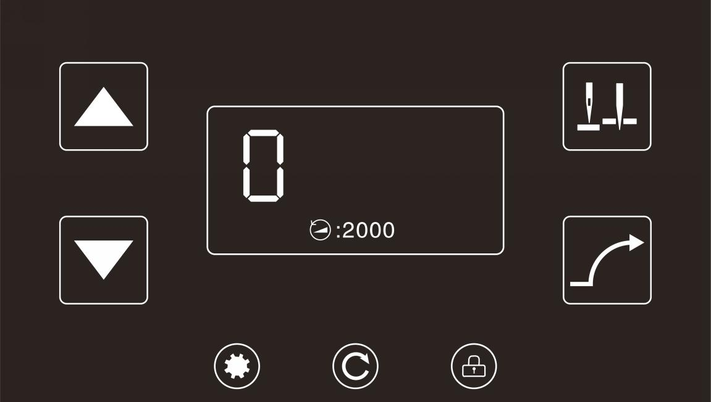
Name | Key | Indicate
Function parameter edit |  | Press this key can enter or exit the user parameter setting interface.
Needle stop position selection |  | Press this key to shift halfway stop needle UP/Down position.
Locking screen  function |  | Press this key to set used or cancelled locking screen function.
Speed increase |  | Press this key to increase the sewing speed.
Speed decrease |  | Press this key to decrease the sewing speed.
Real-time sewing speed display
Slow launch setting |  | Press this key can set used or cancelled slow launch function.
Sewing speed display
1.2 Setting Interface Operating Instructions
Name | Key | Indicate
Return key |  | If clicked, go back to the previous interface
Switch button |  | If clicked, toggle to the next Settings page

2 Simulation Parameters
If the setting key is pressed in other screens, the setting interface will be displayed.
Click the corresponding column to enter the corresponding setting interface.
No. | Setting
1 | Free Sewing Speed
2 | Soft Start Setting
3 | Main Shaft Motor Relative Setting
4 | Pedal Relative Setting
5 | Setting Function of Manual Switch A
6 | Safety Protection Setting
7 | Main Shaft Motor Zero-Point Correction
8 | Interface Display
9 | Manual Switch Function Setting
10 | About System

2.1 Free Sewing Speed
No. | Items | Range | Default | Description
101 | Free Sewing Speed | 100-2200 | 2000

2.2 Soft Start Setting
No. | Items | Range | Default | Description
201 | Soft Start | ON/OFF | OFF
202 | Soft Start Speed | 200-1500 | 400
203 | Stitch Numbers for Soft Start | 0-99 | 2

2.3 Main Shaft Motor Relative Setting
No. | Items | Range | Default | Description
301 | Needles Goes Up Automatically as Power turned On | 0-2 | 0 | 0: No Function.  1: Power turned on, needle goes up position automatically  2: If the motor is already in the upper positioning, it will not find the upper positioning
302 | Up Position Adjustment | 0-1439 | 1120 | Up position adjustment, the needle will advance stop when the value decreased, the needle will delay stop when the value increased.
303 | Down Position Adjustment | 0-1439 | 360 | Down position adjustment, the needle will advance stop when the value decreased, the needle will delay stop when the value increased.
304 | Low (Positioning) Speed | 100-500 | 210 | Minimum speed limit adjustment
305 | Stopping Strength as Half-way | 1-45 | 20

2.4 Pedal Relative Setting
No. | Items | Range | Default | Description
401 | Speed Curve Adjustment (%) | 10-100 | 80 | The higher the slope value, the steeper the velocity; The smaller the slope, the slower the speed.
402 | The Voltage of Forward Step Pedal Point | 30-1000 | 520
403 | The Voltage of Intermediate Step Pedal Point | 30-1000 | 420
404 | The Voltage of Half Heeling Pedal Point | 30-1000 | 270
405 | The Voltage of Heeling Pedal Point | 30-1000 | 130

2.5 Setting Function of Manual Switch A
No. | Items | Range | Default | Description
501 | Setting Function of Manual Switch A | 0-4 | 2 | 0: half stitch;  1: one stitch;  2: continuous half stitch;  3: continuous one stitch;  4: continuous one stitch, quick stop.

2.6 Safety Protection Setting
No. | Items | Range | Default | Description
601 | Machine Protection Switch Testing | 0-2 | 1 | 0: Disable  1: Testing positive signal  2: Testing negative signal
602 | Setting High Voltage Protection Value |  | 880 | After testing external input AC voltage to transfer DC voltage the value out of the setting value, the system will alarm E01 and stop running.

2.7 Motor Zero-Point Correction
No. | Items | Range | Default | Description
701 | Main Shaft Motor Zero-Point Correction | 0-720 | 160 | Reading the initial ngle of encoder, the factory default was set, please do not change the values (parameter value cannot be changed manually, random change it will result the control box and motor abnormal or damaged).

2.8 Interface Display
No. | Items | Range | Default | Description
801 | Brightness | 1-10 | 8
802 | Main Interface Locked Automatically | 0-900 | 0 | 0: Never  1-900: After main interface keep a certain times without operation, the main interface will locked automatically
803 | Language Setting | 0-1 | 0 | 0: Chinese  1: English

2.9 Testing Mode
No. | Items | Range | Default | Description
901 | Testing A | ON/OFF | OFF | Option of Testing A, after setting to set the speed keep running.
902 | Testing B | ON-/OFF | OFF | Option of Testing B, after setting to set the speed execute the cycle of Start – Sewing–Stop–Trimming
903 | Testing C | ON/OFF | OFF | Option of Testing C, after setting to set the speed execute the cycle of Start without positioning function – Sewing–Stop
904 | Testing Speed | 100-2500 | 2000 | Testing speed setting
905 | Running Time of Testing B and C | 1-250 | 20 | For test items B and C, set the running time; if set to 20, then set the running time to 2S
906 | Stop Time of Testing B and C | 1-250 | 20 | In the tests of items B and C, the stopping time is set; if it is set to 20, the stopping time is 2S

2.10 About System
No. | Items | Range | Default | Description
1001 | Version Number |  |  | After entering, control box version number, electronic control copy version number, display board version number and resource version number will be displayed
1002 | State Information
1003 | Advanced Settings |  |  | Enter the "advanced password setting" interface and enter the password. If it is correct, enter the "advanced password setting" interface; if it is wrong, it will be invalid and "password error" will be displayed.

2.10.2 State Information
No. | Items | Range | Default | Description
10021 | Motor Speed Display |  |  | Display the current motor speed
10022 | Needle Position Angel Value |  |  | Display the current motor angle of the machine
10023 | Pedal AD Value |  |  | Display the current pedal AD value
10024 | Busbar Voltage AD Value |  |  | Displays the current busbar voltage AD value

2.10.3 Advanced Settings
No. | Items | Range | Default | Description
10031 | Main Shaft Motor Related Advanced Settings
10032 | Restore Factory Defaults
10033 | Main Shaft Motor Maximum Speed Limit | 100-3500 | 2200

2.10.3.1 Main Shaft Motor Related Advanced Settings
No. | Items | Range | Default | Description
100311 | UP/DOWN Needle Position Distance Value | 100-1400 | 610 | On the up and down needle position shortcut setting interface, save the up needle position value.
100312 | Main Shaft Motor Rotation Direct Setting | CCW/CW | CCW | CW: Clockwise  CCW: Counter Clockwise ( Lockstitch type rotation direction)
100313 | Main Shaft Motor Maximum Current (A) | 0-20 | 16
100314 | Main Shaft Motor Locked rotor Current (A) | 0-20 | 16
100315 | Main Shaft Motor Normal Current (A) | 0-20 | 16
100316 | Main Shaft Motor Encoder Type Selection | 0-1 | 0 | 0: without magnetic ring  1: with magnetic ring

3 Error Code List
Error Code | Problem Description | Measure
E01 | Over-voltage | Turn off the machine, check the power supply voltage. (Or whether exceed the rated voltage of use).  If there are still errors, please replace the control box and call for customer service.
E02 | Low-voltage | Turn off the machine, check the power supply voltage. (Or whether under the rated voltage of use).  If there are still errors, please replace the control box and call for customer service.
E03 | CPU communication error | Turn off the machine, please check if the operation panel in bad connection or is too loose. To get it right and turn on.  If there are still errors, please replace the control box and call for customer service.
E05 | Pedal connection error | Turn off the machine, please check if the pedal in bad connection or is too loose. To get it right and turn on.  If there are still errors, please replace the control box and call for customer service.
E07 | Motor locked-rotor error | Turn the machine handwheel, check if it is stuck. If it is stuck, you have to rule out the mechanical failure. If turn normal, check if the encoder and motor in bad connection or is too loose. If yes, please correct.  If connection well, check if the power supply voltage is abnormal or sewing speed is too high. If yes, please adjust.  If there are still errors, please replace the control box and call for customer service.
E09  E11 | Positioning signal error | Turn off the machine, please check if the encoder in bad connection or is too loose. To get it right and turn on.  If there are still errors, please replace the control box and call for customer service.
E14 | Encoder error | Turn off the machine, please check if the encoder in bad connection or is too loose.  To get it right and turn on. If there are still errors, please replace the control box and call for customer service.
E15 | Power supply module abnormal  over-current | Turn off the machine, then turn on again. If there are still errors, please replace the control box and call for customer service.
E17 | Machine protection switch is not  in the correct position | Turn off the machine, check if the machine is turn over, or the mercury switch is shifted or damaged.
E20 | Motor failed to start (Electrical angle error) | Turn off the machine, please check if the encoder and motor in bad connection or is too loose. To get it right and turn on. If there are still errors, please replace the control box and call for customer service.

